**Contents**

Strategy

2020/23

SOUTHEND

Safeguarding

Partnership

1. Executive Summary 4

2. Operating Context 4

3. The Current Environment 5

4. Internal / External Environment Analysis 6

5. Risk and Opportunity 6

6. Resources 7

7. Strategic Priorities 9

8. The Next 3 Years 10

9. Partnership Delivery Plan 15

**Strategy Supplement - Appendices and Evidence**

Appendix 1 – Strategy Methodology 21

Appendix 2 – Partner Strategy Link Analysis 22

Appendix 3 – SSP – Goverance Structure 24

Appendix 4 – Internal / External Environment Analysis 25

Appendix 5 – SSP (Adults) Board Self-Assessment (2019) 29

Appendix 6 – SSP (Adults) Partners Self-Assessment (2019) 30

Appendix 7 – SSP (Adults) SET – Cohort 1-3 - Staff Survey (2019) 31

Appendix 8 – SETDAB; DHR Thematic Review (Nov. 2019) 32

Appendix 9 – SSP: Case Learning Briefing to Strategic Group (2019) 33

Appendix 10 – Section 11 (Children’s Act) Self-Assessment Summary 36

Appendix 11 – SSP (Children’s) Neglect Strategy: 2019 - 2022 39

Appendix 12 – SSP(Adults) Risk Register (Jan 2020) 40

Appendix 13 – SSP(Children’s) Risk Register (Jan 2020) 47

Appendix 14 – Adults - Contextual Data 53

Appendix 15 – Children - Contextual Data 56

# Executive Summary

* 1. The Southend Safeguarding Partnership (‘the Partnership’ or ‘SSP’) is recognised throughout the Borough as a valuable resource for collaboration, communication and risk assurance. The Partnership gives us invaluable insights and opportunities to engage with each other; learning together, improving knowledge and delivery, and sharing risk.
  2. This Strategy is cognisant of Partners aims and objectives, their assessment of their own ‘safeguarding’ performance and the performance of the Partnership. It has also been exposed to service users through Partner forums and is agreed by all parties as the most appropriate way forward.

# Operating Context

* 1. Governance
     1. The Children and Social Work Act 2017 received Royal Assent in April 2017. Section 30 of the Act removes the requirement for local areas to have Local Safeguarding Children’s Boards (LSCBs). Sections 16 – 23 introduce a duty on 3 key partners (Local Authorities, Police and CCGs) to make arrangements with other partners as locally determined, to work together in a local area to protect and safeguard children. These arrangements must identify and respond to the needs of children in the area and also identify and review serious child safeguarding cases which raise issues of importance in relation to the area.
     2. The DfE issued draft statutory guidance in October 2018, produced a response to the consultation in February 2018 and a final version of Working Together 2018. Working Together to Safeguard Children 2018 was issued at the end of June 2018. The revised statutory guidance sets out the requirements for the 3 safeguarding partners, while allowing them freedom to determine how they organise themselves to meet those requirements and improve outcomes for children locally.
     3. A Southend, Essex and Thurrock (SET) summit took place in June 2018 and agreed all areas would remain independent but working together might offer opportunity to achieve some economies of scale. Partners agreed to begin planning the introduction of the new arrangements. At the Southend LSCB Executive in July 2018 it was agreed a paper would be presented to their September meeting that summarised the comments received from Partners at the July meeting and to give options for the way forward. The paper was then presented to the Southend LSCB Board with recommendations from the Executive and subsequently to Partners for their consideration.
     4. Under the terms of the Care Act 2014, each Local Authority must set up a Safeguarding Adult Board (SAB), with core membership from the Local Authority, Police and the National Health Service (specifically the local Clinical Commissioning Group/s).
     5. The Strategic Leads of the Southend LSCB and SAB agreed they would take the opportunity to change the Governance of both groups at the same time; taking the opportunity to work more closely together. On October 31, 2019 the transition was made: The Southend Safeguarding Partnership (Adults) and (Children) is now in place (Appendix 3).

# The Current Environment

* 1. Health - The health of people in Southend-on-Sea is varied compared with the England average. About 19% (6,300) of children live in low income families. Life expectancy for men is lower than the England average.
  2. The rate of alcohol-related harm hospital stays is 536 per 100,000, better than the average for England. This represents 941 stays per year. The rate of self-harm hospital stays is 126 per 100,000, better than the average for England. This represents 220 stays per year. Estimated levels of adult smoking are worse than the England average. The rate of people killed and seriously injured on roads is worse than average. Rates of sexually transmitted infections and TB are better than average. The rate of violent crime is worse than average. The rate of statutory homelessness is better than average.
  3. Population

|  |  |  |
| --- | --- | --- |
|  | Southend on Sea | England |
| Population (2016) | 181 | 55,268 |
| Projected Population (2020) | 186 | 56,705 |
| % under 18 | 21.5% | 21.3% |
| % 65+ | 19.1% | 17.9% |
| % from ethnic minority | 7.1% | 13.6% |

* 1. Index of Multiple Deprivation

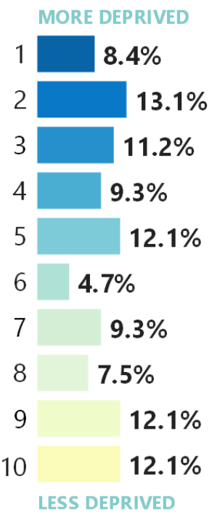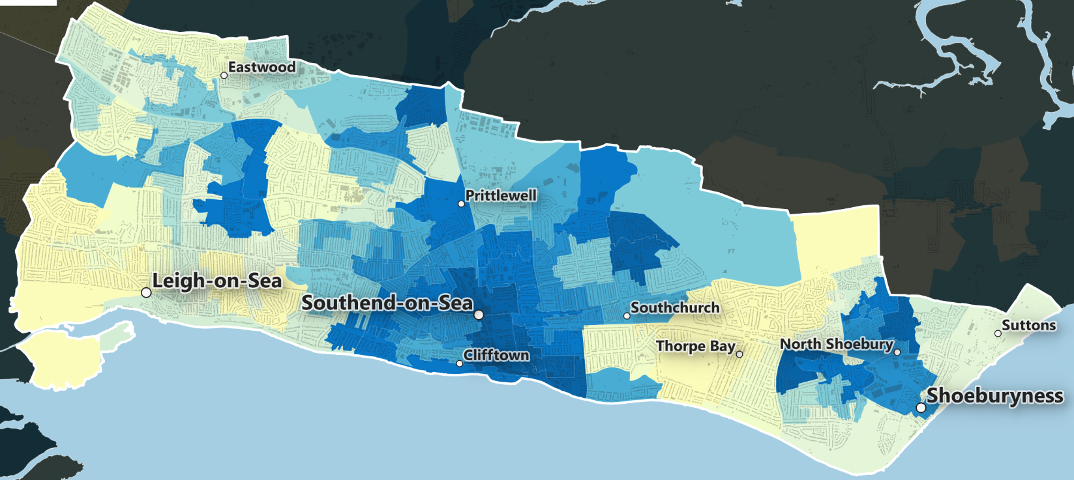

* 1. Safeguarding Referral rates for Southend on Sea

|  |  |  |
| --- | --- | --- |
|  | | 2018/19 |
| Safeguarding concerns (adults) | | 1350 |
| Rate of safeguarding concerns (adults) (per 100,000) | | 944.6 |
| Safeguarding enquiries (adults) | | 760 |
| Rate of safeguarding enquiries (adults) (per 100,000) | | 531.8 |
| Rate of safeguarding referrals (children ) (per 10,000) | 544.5 |
| % SSWA in 45 days (Single Social Work Assessment) | 83.1 |
| Number of re-referrals for children (within 12 months) | 24.4% |

# Internal / External Environment Analysis

* 1. A SWOT and PESTLE analyses have been completed, offering a systematic and thorough evaluation of the operating context in which the Southend Safeguarding Partnership operates. The SWOT analysis focused on the Partnerships internal strengths and weaknesses, and the PESTLE analysis concentrated on external factors. (Appendix 4)
  2. Outcomes of this analysis include:
     1. There is a great deal Partners already share, including: Visions, Aims, Objectives, Clients, Space, and Networks etc. The SSP supports and can develop further the collaborative work of the Partners.
     2. The Southend Safeguarding Partnership is mature and functioning well; any activity should be cognisant of the benefits this strong Partnership could afford; it should equally be aware of any risk to the Partnership.
     3. Funding is a challenge, shared funding of services has proven difficult (not only in this arena); the Partnership can prove that working together can be more effective and efficient.
     4. All the elements of a good Partnership are in place (Supportive, Rewarding, Cohesive, Open, Protective, Challenging, Catalyst for Improvement and Morale). The advantages of working together are clear to Partners and should be exploited in the work of the SSP.
     5. Successful delivery of services can only be done with the ‘permission’ of the vulnerable person. The trusted brand of the SSP will support Partners to engage the service user.

# Risk and Opportunity

## Risk

* 1. This Strategy is cognisant of the risks that present themselves to the successful delivery of SSP activity. Risk Registers are maintained separately by the Children and Adults Partnerships (Appendices 12 and 13).
  2. The significant risks (after appropriate control measures are put in place) that may impact on the successful delivery of this strategy are:
     1. Case Review Resources: A significant proportion of the work of the Children’s Safeguarding Partnership appears in an unplanned way (Serious Case Reviews, Practitioner Reviews and Serious Incident Reviews). Serious Adult Reviews and Domestic Homicide Reviews appear less often, and so have less of an ‘unplanned’ impact for the Adults Safeguarding Partnership.
     2. Project Resources; Partners will need to allocate resources for the successful delivery of this strategy. The methodology used to develop this strategy clearly links partner’s strategies to that of the Partnership; this should help in their assignment of resources.
     3. Voice of the Service User: Like all safeguarding activity the voice of the service user should have a significant impact on the delivery of the service. The inclusion of all Partners and the use of their user forums will support this approach in the delivery of the Strategies.
     4. Training and Skills: The Risk Registers, Self-Assessments and Surveys all identify training is an area that requires attention. The lack of competence and skill to deliver services and this Strategy will be carefully monitored.
     5. Partner’s internal arrangements: Whilst this strategy deals predominantly with improvement, there is a need not to lose sight of current delivery (business as usual) and standards. In the same way performance management only measures that which it defines as important and can take resources from other work; this Strategy must be aware there is work outside the delivery of its priorities that must be completed.
     6. Data and Information: The delivery of the new Dashboards will impact significantly on the availability of up to date information and reduce any risk of being ‘surprised’ by poor performance.

## Opportunity

* + 1. The SWOT and Pestle analysis has identified a number of strengths of the Partnership: There is opportunity to exploit these strengths, and to use a strengths based approach to the deliver the Strategy. These include:
    2. A shared service user; and so clear operational and financial benefit for Partners in multi-agency delivery.
    3. Potential efficiencies in multi-agency delivery of training and personal professional development.
    4. Network centre for Partners: Spending time in a professional setting with Partners, builds the professional relationship and trust and is proven to improve outcomes for those supported. A strong SSP will facilitate many of these opportunities.
    5. Delivery of shared view: Safeguarding matters that arise from vulnerable people and children, often with chaotic lives and complex issues, can be interpreted differently by agencies. Working together will help share a common view and so a common approach to a shared intervention and outcome.
    6. Safe place for challenge: A strong SSP will allow for appropriate challenge between Partners. This will facilitate improvement without waiting for external review or matters to go wrong before areas are highlighted. This might include assurance mechanisms such as Self-assessment, Challenge Events and Peer Reviews.

# Resources

* 1. Strategic Partners agreed in 2018 the resources needed to deliver the work required should be reviewed. As a result of the review an opportunity was taken whilst there were changes in staff, two Business Managers were employed. One who would concentrate on issues of Safeguarding Children, and the other issues of Safeguarding Adults. Business Support (1 x FTE) was also agreed.
  2. In 2019 changes were made to the SSP’s Governance (*as a response to Working Together 2018*), membership, sub-groups, work plans and management; also aligning with the priorities set out in the Partners Strategic Plans (see Appendix 3).
  3. If any Strategic Partner identifies a reason to review these arrangements, the work will be completed by the Business Managers.
  4. Finance:
     1. There are no plans to change the Budget from that of 2018/19.
     2. The Budget included a number of areas that, if expenditure were identified, Partners would be approached to meet additional costs. These are included in the plan below:

|  |  |  |  |  |  |
| --- | --- | --- | --- | --- | --- |
| **Expenditure** | | | | | |
| Professional Independent Advisor | | | | | £58,120 |
| Salaries (INCL 34% ON COSTS) | | | | | £155,396 |
| Car Allowances/Subsistence | | | | | £1400 |
| Travel Expenses | | | | | £0 |
| Event - Room / Equipment Hire  *Costs will be recovered in year with agreement from Partners at ‘Partnership Group’ level* | | | | | £0 |
| Event - Speaker expenses  *Costs will be recovered in year with agreement from Partners at ‘Partnership Group’ level* | | | | | £0 |
| Event – Catering | | | | | £1,700 |
| Web Design (Host) | | | | | £1,000 |
| ICT: ChronoLator Licence | | | | | £1,200 |
| ICT: Hardware | | | | | £1,600 |
| Association of Independent LSCB Chairs | | | | | £1,500 |
| Professional Subscriptions | | | | | £500 |
| Health & Safety | | | | | £500 |
|  | | | | |  |
| **Total £222,916** | | | | | |
| **In Kind (Goods and Services Provided)** | | | | | |
| CSPR Reviewer (3 x 20 days @ £600)  *If this does not cover all reviews an application will be made to Partners* | | | £36,000 | | |
| Human Resource Management (4fte @£1,218ea) | | | £4,872 | | |
| Professional Fees: Legal Services | | | £11,000 | | |
| Office Space (3 Desks @ £1,600ea) | | | £4,800 | | |
| Meeting Expenses: Room / Equipment Hire | | | £1,500 | | |
| Meeting Expenses: Catering/Hospitality  *Costs will be recovered in year with agreement from Partners at ‘Partnership Group’ level* | | | £0 | | |
| Training provided by Southend Borough Council  *Costs will be recovered in year with agreement from Partners at ‘Partnership Group’ level* | | | £0 | | |
| Employee Benefits (incl. absence mgt., appraisal) | | | £500 | | |
| Office Expenses: Telephone charges | | | £400 | | |
| Office Expenses: Mobile Phone | | | £500 | | |
| Office Expenses: Stationery | | | £1,000 | | |
| Office Expenses: Postage | | | £200 | | |
| Office Expenses: Printing | | | £500 | | |
| Insurance | | | £200 | | |
| Sundries | | | £500 | | |
| Recruitment | | | £0 | | |
| Criminal Records Bureau Checks | | | £54 | | |
| Security | | | £14 | | |
| **Total**  **£62,040** | | | | | |
| **Grand Total £284,956** | | | | | |
| **Income** | | | | | |
| Southend Borough Council (48% after minor ‘Others’ contributions) | | | | £133,038 | |
| Essex Police (26% after minor ‘Others’ contributions) | | | | £72,062 | |
| NHS Southend CCG (26% after minor ‘Others’ contributions) | | | | £72,062 | |
| Others: | DSG | 0 | |  | |
|  | CAFCASS | £805 | |
|  | Essex CRC | £4,577 | |
|  | National Probation Service | £2,412 | |
|  | Schools & Colleges | 0 | |
| Others: Sub-Total | | | | £7,794 | |
| **Total** £284,956 | | | | | |

# Strategic Priorities

* 1. SSP Aim
     1. To support Local Agencies deliver a safe place for people in Southend; free from abuse and harm.
  2. SSP Mission
     1. Assuring itself that local safeguarding arrangements are in place as defined by the Children’s Act 2004, the Care Act 2014 and statutory guidance.
     2. Assuring itself that safeguarding practice is person-centred and outcome-focused.
     3. Working collaboratively to prevent the abuse and neglect of children and people with care and support needs whenever possible.
     4. Ensuring agencies and individuals give timely and proportionate responses when abuse or neglect has occurred.
     5. Assuring itself that safeguarding practice is continuously improving and enhancing the quality of life of people in Southend.
     6. Supporting Case Reviews for children and adults.
  3. The Strategic Plan has been developed as a result of analysis of Partners Strategic Aims and Objectives, Audits, Self-Assessments and inspections of Partner Agencies and consultation with service users.
  4. The outcome of this analysis is a list of themed areas that require strategic consideration of the SSP over the next three years. The table that follows demonstrates where the themed areas are driven from:

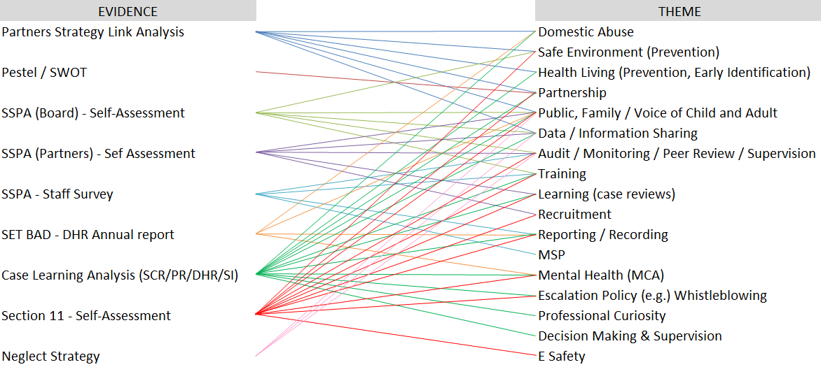

# The Next 3 Years

* 1. The SSP has statutory responsibilities that it will deliver, alongside themed areas that have been highlighted in the evidence gathered. These Statutory Responsibilities will be delivered through the agreed Governance Structure (Appendix 3) and are not detailed in this Strategic Plan as they are regarded as ‘business as usual’.
     1. Southend Safeguarding Partnership - Children
        1. The SSP (Children) (SSPC) aim is to ensure local children and young people are safe, cared for, and protected from abuse, neglect, violence, and sexual exploitation. It also works to reduce the chances of children being harmed by exposure to crime and anti-social behaviour, bullying and discrimination, and accidental death and injury.
        2. In order to promote a depth of knowledge and a comprehensive provision across such a range of issues, the SSP group operates several subgroups to tackle individual aspects of child protection. These subgroups range from those advising on safer recruitment and private fostering arrangements, to those providing guidance for allegations against professionals and monitoring children who may be sexually exploited or missing from education, to those whose duty it is to respond to the lessons learnt through Serious Case/Practice Reviews and Child Death Panels.
        3. It is the aim of SSP to offer information and guidance for those who are in need of it, whether they are professionals, voluntary workers, parents, friends and family, or children.
     2. Southend Safeguarding Partnership - Adults
        1. SSP (Adults) (SSPA) aims to ensure the safety and protection of local adults and particularly adults with care and support needs and who are subsequently less able than others to defend themselves against the threat of abuse, exploitation, or neglect. It achieves this by working with the Police, Health, Social Care and other Partners including voluntary agencies to ensure that adults, their support agencies and the wider community can raise awareness about abuse; develop a culture that does not tolerate abuse; and to prevent abuse from happening wherever possible.
        2. Where abuse does happen, the SSPA and their partner agencies are able to support and safeguard the rights of people who are harmed; stop abuse from continuing; and improve the victim’s access to any services they may need, such as advocacy, post-abuse support, or legal services.
        3. With the implementation of the Care Act on April 1st 2015, Safeguarding Adults Boards across the country were given statutory powers and responsibilities, helping them to operate in much the same way that Local Safeguarding Children Boards do. The SSPA can launch a Case Review in cases where there is suspicion that abuse or neglect has caused death or serious injury to adults with care and support needs, and may change practice, policy, or protocols accordingly, as well as:
           1. Consult with adults with care and support needs and their carers to ensure that the safeguarding process is as efficient as possible.
           2. Constantly review Southend, Essex and Thurrock (SET) Safeguarding Adults Procedures to ensure they are up to date.
           3. Act on feedback from Action Groups
           4. Ensure training carried out across Southend meets the SET Training Strategy.
           5. Link the work of the SSPA to the wider crime and disorder reduction work.
  2. Domestic Abuse (DA)
     1. DA was raised as a key issue in Partners Strategies (Local Authority / Police / NHS / Crime Safety Partnership) and The Domestic Homicide Annual Review.
     2. DA is very common, with one in four women experiencing it in their lifetime and around one in nine women experiencing it annually. Although less than half of all incidents are ever reported to the Police, a call about domestic abuse is received by the Police throughout the UK at a rate of one a minute.
     3. SSP will support the work of SETDAB (<https://setdab.org/>): It is important that all Partners understand each other’s role and how they can work together to get the best outcomes.
     4. It is recognised that DA often impacts on the victim’s wider family (children, family and friends).
     5. **SSP will seek assurance from all agencies that the outcomes desired by the victim are achieved and all those affected by the abuse are considered.**
     6. **SSP will seek assurance from all agencies that the signs and symptoms of DA are recognised by front line staff; and they are aware of the appropriate response and reporting route.**
  3. Safe Environment / Health Living (Prevention, Early Identification)
     1. Safe Environment and Prevention (SEP) was raised as an issue in the Local Authority 2050 Strategy, the Safeguarding Adults Board Self-Assessment and S11 Assessments.
     2. **SSP will work with Partner Agencies to ensure we learn from available information and recognise the environment and context where abuse is most likely to occur; this informs the shape and place of their service delivery.**
     3. **SSP will seek assurance that, where appropriate, Partners deliver early interventions that are designed to prevent abuse and appropriately sized and targeted.**
  4. Partnership
     1. Working together (Partnership) to overcome issues of Safeguarding was an issue raised in all Strategic Partners Strategies, a number of Case Reviews and S11 Audits and as an opportunity in the PESTLE and SWOT analysis.
     2. 2019 saw the introduction of a new Governance framework for SSP (live from Oct 2019) that will support the development of Partnerships in the next 3 years.
     3. SSP agencies often support the same client with chaotic lives and complex issues that cannot be supported separately.
     4. **SSP will look for every opportunity to encourage and support Partnership working. This includes seeking assurance that Partners work together where appropriate and are cognisant of each other’s interaction with their clients.**
  5. Public, Family, Voice of the Child / Adult (including Making Safeguarding Personal)
     1. Almost all (apart from the Staff survey and PESTEL/SWOT analysis) sources of evidence talk about the ‘inclusion of the victim’ in the solution and that consideration of the wider impact of the abuse (family, friends and community) should be developed.
     2. **SSP will challenge all Agencies to demonstrate how the voice of the victim directs services, solutions, policy, guidance and learning.**
     3. **SSP will challenge all Agencies to demonstrate how they consider the wider (children, family, friends and community) impact of abuse**
  6. Data / Information Sharing
     1. All Strategic Partners Strategies, the SSP(A) Partner and Board Self Assessments, Case Reviews and the Neglect Strategy mention the need to develop our data and information sharing.
     2. The SSP understand the General Data Protection Regulation, 2018 (GDPR) states that data subjects have a right not to be subject to automated decision making or profiling, whereas the Data Protection Act 2018 (DPA) allows for this whenever there are legitimate grounds for doing so and safeguards are in place to protect individual rights and freedoms.
     3. **SSP challenge Partners data and information sharing protocols; seeking assurance that all appropriate information is shared, and they take a pro-active approach to their management of personal data for the benefit of their clients.**
  7. Audit / Monitoring / Peer Review / Supervision
     1. All four Self-Assessments (SSP(A) Partners and Board, Section 11 (Children’s) and staff survey) raised the issue of appropriate monitoring of organisational and personal performance.
     2. The work of Partners around issues of Safeguarding is monitored carefully and often by more than one agency.
     3. **SSP will consider all monitoring activity (from victim outcomes and personal service delivery to organisational inspections), review with Partners and where appropriate develop a Partner Action Plan.**
  8. Training
     1. Appropriate or an increase in training was raised by the SSPA, the Staff Survey, in a number of Case Reviews and in the Children’s Section 11 self-assessments.
     2. The SSP recognise that quality of service offered depends on appropriate policies, procedures and then the appropriate application of these. This will only be achieved if there are sufficient and competent members of staff and good quality management. To achieve this, all staff must be trained and receive refresher and update training.
     3. Part of the current activity of the SSP is to monitor the training of service providers’ staff.
     4. **SSP will continue to monitor training Partners provide their staff and seek assurance that all appropriate training is provided.**
     5. **SSP will promote regular opportunities (Conferences and Training) in areas where need is highlighted.**
  9. Learning (Case Reviews)
     1. Serious Case Reviews, Practitioner Reviews, Domestic Homicide Reviews and Serious Adult Reviews all highlight opportunity to improve. These reviews will all develop their own Action Plans and they will be monitored by the SSP.
     2. When a number of reviews highlight the same issue, the SSP will add weight and momentum to the work of improvement.
     3. **As a result of the outcomes of recent reviews, the SSP will seek assurance From partners that support Partners work on the learning from Reviews are understood and appropriate action taken. Recent Reviews have highlighted learning in the following areas:**
        1. **Harmful Sexual Behaviour**
        2. **Professional Curiosity**
        3. **Including the voice of the victim in the design and delivery of the solution**
        4. **Neglect**
  10. Recruitment
      1. In both Adults and Children’s Partners’ Self-Assessments the issue of Recruitment came up as requiring improvement.
      2. **SSP will ask Partners to review their recruitment services, seeking assurance that appropriate training, policies and procedures are in place.**
  11. Reporting / Recording
      1. In both Adults and Children’s Partners Self-Assessments the issue of Reporting and Recording came up as requiring improvement.
      2. A number of Partners are not reporting their staff a re confident that they are reporting Safeguarding Issues at the right time, in the right way and in the right format 100% of the time.
      3. SSP will explore, alongside Partners, the issue of reporting and then recording. The manner of this exploration will be decided by Partners.
      4. **SSP will seek assurance that all Partners staff are aware of the correct Policy and Procedures for reporting and recording Safeguarding Issues; and are trained and activity monitored.**
  12. Mental Health (Including the mental Capacity Act)
      1. Both Case Reviews and the Section 11 Children’s Self-Assessment highlighted the link between Mental Health and abuse requires development.
      2. There is significant evidence that those who are suffering from poor mental health are more likely to suffer abuse. They are also likely to suffer poor mental health having suffered abuse.
      3. **SSP will review the consideration of safeguarding issues when mental health services are provided; particularly the recognition of signs and symptoms of harm.**
  13. Escalation (Including Whistleblowing)
      1. Case Reviews and the Section 11 Reviews highlighted issues of escalation.
      2. In many assessments of a vulnerable person or child’s need, a subjective decision is made. Where there is disagreement with this subjective decision there should be a clear route to resolve the issue. This route should be known by all and be seen to be working.
      3. The nature of Legislation, Statutory Guidance, Policy and Procedure makes the provision of services for children often more complex; and so more susceptible to disagreement.
      4. **SSP will seek assurance that all policies and processes of escalation are clear, known and working.**
  14. Professional Curiosity
      1. Professional Curiosity has only been raised by evidence from Case Reviews. It does however come up regularly as a factor that may have influenced the outcome under review.
      2. The Partnership is aware of the drivers for and the factors that work for/against appropriate professional curiosity, including:
         1. A victim focused approach within a safe environment
         2. Exploring what is not exposed
         3. Exploration of everyone’s perspective
         4. Working with families and carers to design and implement interventions
         5. Critical thinking skills, sensitivity and persistence
         6. Judgements based on evidence not optimism
      3. **SSP will explore with Partners how they ensure practice is appropriately professionally curious. (see 8.15)**
  15. Decision Making and Supervision
      1. Decision Making and Supervision was only identified in evidence from Case Reviews.
      2. Management support for Practitioners decision making often form part of the organisational management supervision.
      3. Safeguarding Supervision is often blended into this management supervision.
      4. Whilst the solution for those in need, are often designed and delivered in Partnership, there is little management or safeguarding supervision delivered in Partnership.
      5. **SSP will explore how all Partners deliver Safeguarding Supervision and identify areas for improvement and potential for shared working.**
  16. E Safety
      1. E Safety only came up in evidence from Section 11 Self-Assessment; but came up a number of times.
      2. The increase use of social/digital media by our communities, and the lack of services that meet the need of the service if abused, is recognised as a potential future significant issue.
      3. **SSP will review current provision of E Safety services; how E Safety can impact on the safety of their service users (or potential service users) and what action maybe required.**

# Partnership Delivery Plan

This Plan concentrates on continuous improvement, provision of assurance to the SSP and taking action, in order that learning from the various policies and processes can be shared among Partners; and people of Southend are free from harm and abuse.

|  |  | Year 1 | | | | Year 2 | | | | Year 3 | | | |
| --- | --- | --- | --- | --- | --- | --- | --- | --- | --- | --- | --- | --- | --- |
| Theme | Activity | Qtr.1 | Qtr.2 | Qtr.3 | Qtr.4 | Qtr.1 | Qtr.2 | Qtr.3 | Qtr.4 | Qtr.1 | Qtr.2 | Qtr.3 | Qtr.4 |
| **9.1 Domestic Abuse**  *SSP will seek assurance from all agencies that the outcomes desired by the victim are achieved and all those affected by the abuse are considered.* |  |  |  |  |  |  |  |  |  |  |  |  |  |
| Review of outcomes (measured against victims desired solution) |  |  |  |  |  |  |  |  |  |  |  |  |
| Review of (Solution to DA) plan (against identification of wider impact assessment) |  |  |  |  |  |  |  |  |  |  |  |  |
| *SSP will seek assurance from all agencies that the signs and symptoms of DA are recognised by front line staff; and they are aware of the appropriate response and reporting route.*  *(It is important that all Partners understand each other’s role and how they can work together to get the best outcomes.)* | SSP will work with MARAT to deliver a conf. / training around the signs and symptoms of DA for all partners. |  |  |  |  |  |  |  |  |  |  |  |  |
| SSP will work with MARAT to ensure that the appropriate reporting route is available to all Partner Front line staff |  |  |  |  |  |  |  |  |  |  |  |  |
|  |  |  |  |  |  |  |  |  |  |  |  |  |
| **9.2 Safe Environment / Health Living (Prevention, Early Identification)**  *SSP will support agencies early interventions that are designed to prevent abuse.* |  |  |  |  |  |  |  |  |  |  |  |  |  |
| SSP will work with Partners Agencies to ensure we learn from available information and recognise the environment and context where abuse is most likely to occur; and this informs the shape and place of their service delivery. |  |  |  |  |  |  |  |  |  |  |  |  |
| SSP will seek assurance that, where appropriate, Partners deliver early interventions that are designed to prevent abuse are appropriately sized and targeted. |  |  |  |  |  |  |  |  |  |  |  |  |
|  |  |  |  |  |  |  |  |  |  |  |  |  |
| **9.3 Partnership**  *SSP will look for every opportunity to encourage and support Partnership working. This includes seeking assurance that Partners work together where appropriate and are cognisant of each other’s interaction with their clients.* |  |  |  |  |  |  |  |  |  |  |  |  |  |
| SSP will work alongside Partners to identify where there would be an advantage to work collaboratively |  |  |  |  |  |  |  |  |  |  |  |  |
| SSP will seek assurance that Partners actively consider external agency involvement and engagement with their clients. |  |  |  |  |  |  |  |  |  |  |  |  |
|  |  |  |  |  |  |  |  |  |  |  |  |  |
| **9.4 Public, Family, Voice of Child / Adult (including Making Safeguarding Personal)**  *SSP will challenge all agencies to demonstrate how the voice of the victim directs services, solutions, policy, guidance and learning.*  *SSP will challenge all agencies to demonstrate how they consider the wider (children, family, friends and community) impact of abuse* |  |  |  |  |  |  |  |  |  |  |  |  |  |
| SSP will review Partners inputs into interventions (against their need to include the wider impact of need and the voice of the person in the intervention) |  |  |  |  |  |  |  |  |  |  |  |  |
| SSP will seek assurance that Partners actively explore other agencies involvement and / or engagement with their clients. |  |  |  |  |  |  |  |  |  |  |  |  |
|  |  |  |  |  |  |  |  |  |  |  |  |  |
| **9.5 Data / Information Sharing**  *SSP challenge Partners data and information sharing protocols; seeking assurance that all appropriate information is shared, and they take a pro-active approach to their management of personal data for the benefit of their clients.* |  |  |  |  |  |  |  |  |  |  |  |  |  |
| SSP will gather details about what information is held by Partners. |  |  |  |  |  |  |  |  |  |  |  |  |
| SSP will work with Partners to determine if there are opportunities to change data stored and shared (for the benefit of the person to whom the data refers.) |  |  |  |  |  |  |  |  |  |  |  |  |
|  |  |  |  |  |  |  |  |  |  |  |  |  |
|  |  |  |  |  |  |  |  |  |  |  |  |  |  |
| **9.6 Audit / Monitoring / Peer Review / Supervision**  *SSP will consider all monitoring activity (from victim outcomes and personal service delivery to organisational inspections), review with Partners and if appropriate develop a Partner Action plan.* | SSP will deliver the following reviews and track the linked action plans. |  |  |  |  |  |  |  |  |  |  |  |  |
| New Dashboard for Children’s and Adults Partnerships |  |  |  |  |  |  |  |  |  |  |  |  |
| SSP Governance Review |  |  |  |  |  |  |  |  |  |  |  |  |
| SSP (Adults) Annual Review |  |  |  |  |  |  |  |  |  |  |  |  |
| SSP (Children’s) Section 11 Review |  |  |  |  |  |  |  |  |  |  |  |  |
| SSP (Children’s) Education Section 175 Review |  |  |  |  |  |  |  |  |  |  |  |  |
| SSP Supervision Review |  |  |  |  |  |  |  |  |  |  |  |  |
| SSP will explore opportunity for Review challenge events and peer review |  |  |  |  |  |  |  |  |  |  |  |  |
| **9.7 Training**  *SSP will continue to monitor training Partners provide their staff and seek assurance that all appropriate training is provided.* |  |  |  |  |  |  |  |  |  |  |  |  |  |
| SSP will include training provision in the Dashboard reporting and so the AQA overview of Partner provision |  |  |  |  |  |  |  |  |  |  |  |  |
| *SSP will promote regular opportunities (Conferences and Training) in areas where need to highlighted.* | Where issues arise or are highlighted by Partners opportunity to provide conferences and/or training will be explored and if appropriate provided. |  |  |  |  |  |  |  |  |  |  |  |  |
|  |  |  |  |  |  |  |  |  |  |  |  |  |
|  |  |  |  |  |  |  |  |  |  |  |  |  |  |
| **9.8 Learning (Case Reviews)**  *As a result of the outcomes of recent reviews the SSP will seek assurance From partners that the learning from Reviews are understood and appropriate action taken. Recent Reviews have highlighted learning in the following areas:*   * *Harmful Sexual Behaviour* * *Professional Curiosity* * *Including the voice of the victim in the design and delivery of the solution* * *Neglect*   *(If any other issues are highlighted during the course of the delivery of this strategy these will also be supported in the same way)* |  |  |  |  |  |  |  |  |  |  |  |  |  |
| The learning identified in Case Reviews will be managed through their action plans. The action plans will be managed through the SSP |  |  |  |  |  |  |  |  |  |  |  |  |
|  |  |  |  |  |  |  |  |  |  |  |  |  |
| **9.9 Recruitment**  *SSP will ask partners to review their recruitment services, seeking assurance that appropriate training, policies and procedures are in place.* |  |  |  |  |  |  |  |  |  |  |  |  |  |
| SSP will review the how recruitment of Partners fits with appropriate safeguarding controls. |  |  |  |  |  |  |  |  |  |  |  |  |
|  |  |  |  |  |  |  |  |  |  |  |  |  |
| **9.10 Reporting / Recording**  *SSP will ensure that all Partners are aware of the correct policy and procedures for reporting and recording Safeguarding Issues; and their staff are trained and activity monitored.* |  |  |  |  |  |  |  |  |  |  |  |  |  |
| SSP will seek assurance that all Partners confirm that front line staff are aware of the correct reporting route for Safeguarding Issues |  |  |  |  |  |  |  |  |  |  |  |  |
| SSP will seek assurance that there is a written and available route map for Safeguarding Issues |  |  |  |  |  |  |  |  |  |  |  |  |
|  |  |  |  |  |  |  |  |  |  |  |  |  |
|  |  |  |  |  |  |  |  |  |  |  |  |  |  |
| **9.11 Mental Health (Including MCA)**  *SSP will review the consideration of safeguarding issues when mental health services are provided; particularly the recognition of signs and symptoms of harm.* |  |  |  |  |  |  |  |  |  |  |  |  |  |
| Assurance sought that all Mental Health Services providers to be trained in recognising the symptoms of abuse, and to understand the route map for reporting and recording (see 9.10) |  |  |  |  |  |  |  |  |  |  |  |  |
| Work with Mental Health Services Providers that are Partners of SSP to identify the vulnerabilities that make sufferers of poor mental health more susceptible to abuse. And plan prevention activity |  |  |  |  |  |  |  |  |  |  |  |  |
|  |  |  |  |  |  |  |  |  |  |  |  |  |
| **9.12 Escalation (Including Whistleblowing)**  *SSP will work with Partners to ensure that all policies and processes of escalation are clear, known and working.* |  |  |  |  |  |  |  |  |  |  |  |  |  |
| SSP will work with Partners to ensure that intervention decision making is cognisant of all appropriate opinions, suitably monitored, and has well-trodden routes that allow difference of opinion to be resolved quickly and efficiently |  |  |  |  |  |  |  |  |  |  |  |  |
|  |  |  |  |  |  |  |  |  |  |  |  |  |
| **9.13 Professional Curiosity**  *SSP will explore with Partners how they ensure practice is appropriately professionally curious.* |  |  |  |  |  |  |  |  |  |  |  |  |  |
| SSP will work with Partners to identify the elements of professional curiosity that can be measured and monitored. |  |  |  |  |  |  |  |  |  |  |  |  |
| SSP will explore opportunity to monitor identified activity and include in regular review / reports |  |  |  |  |  |  |  |  |  |  |  |  |
| SSP will encourage Partners to ensure that all supervision and performance management activity considers professional curiosity |  |  |  |  |  |  |  |  |  |  |  |  |
|  |  |  |  |  |  |  |  |  |  |  |  |  |
|  |  |  |  |  |  |  |  |  |  |  |  |  |  |
| **9.14 Decision Making and Supervision**  *SSP will explore how all Partners deliver Safeguarding Supervision and identify areas for improvement and potential for shared working.* |  |  |  |  |  |  |  |  |  |  |  |  |  |
| SSP will explore how Partners deliver Safeguarding supervision; and whether there are outcome benefits is working more closely together |  |  |  |  |  |  |  |  |  |  |  |  |
|  |  |  |  |  |  |  |  |  |  |  |  |  |
| **9.15 E-Safety**  *SSP will review current provision of E Safety services; how E Safety can impact on the safety of their service users (or potential service users) and what action they may take* |  |  |  |  |  |  |  |  |  |  |  |  |  |
| SSP will explore with Partners the impact of social media on abuse of people in Southend. |  |  |  |  |  |  |  |  |  |  |  |  |
| SSP will gather partners prevention activity around digital media and explore opportunity to work together to identify the audience and deliver the service |  |  |  |  |  |  |  |  |  |  |  |  |
|  |  |  |  |  |  |  |  |  |  |  |  |  |  |

# Appendix 1 – Strategy Methodology

## Strategic Review

### Review delivery of Strategy 2018/19 - Potentially use Annual Plans (Adults / Children’s) 2019 to summarise

### Adults/Children’s Boards Self-Assessment - Include recommendations

### SSP(C) - Section 11 Self Assessments

### SSP(A) Partner Self-Assessment - Include outcomes that are relevant

### Partner Annual Report - Include outcomes that are relevant to SAB/LSCB

### SSP (A) and (C) Annual Report - Include outcomes that are relevant

## SSP Dashboards - Highlight opportunities and challenges

## Visioning

Involve as many Partners as possible in the creation of the Vision for the Southend Safeguarding Partnership. Asking:

*Visioning Brief*

*To create:*

* *A Partn*ership *that reduces exploitation and abuse, and manages crisis to the satisfaction of the victim*
* *A Partnership that adds value to all Partners and encourages engagement (Partners get more out than they put in, and delivers what they can’t achieve on their own)*
* *A Partnership that delivers against National, Regional, Local priorities (satisfies Legislation and Guidance)*

1. *Do you agree with this vision? (If not what would you add, omit or alter?)*

*In order to achieve the brief:*

1. *Name two things the Southend Safeguarding Partnership should start doing:*

*A1.*

*A2.*

1. *Name two things the Southend Safeguarding Partnership should stop doing:*

*B1.*

*B2.*

## Name two things the Southend Safeguarding Partnership should keep doing:

*C1.*

*C2.*

## Draft

Produce a Draft Strategy and submit to the Strategic Leadership and Partnership meetings for approval

## Consultation

Use outcomes from Strategic Review and Visioning Events to construct a consultation exercise *(Survey / Email / Partner Engagement / (SSPA and SSPC Subgroups)*

## Publish

* Present to Boards
* Publish on Website
* Post to Partners

# Appendix 2 – Partner Strategy Link Analysis





# Appendix 3 – SSP – Goverance Structure

## 

# Appendix 4 – Internal / External Environment Analysis

## SWOT Analysis

|  |  |
| --- | --- |
| **STRENGTHS**   * *Delivery Model based in the Care Act, Children’s Act and working Together 2018 Document* * *Highly motivated team and Network* * *Shared vision and mission* * *Past Successful delivery building confidence* | **WEAKNESSES**   * *Limited Funding* * *Limited resources (People and Time)* * *Plethora and competition of externally driven agendas experienced by partners* * *Competing Priorities* * *Workload of Partners* * *Maintaining engagement* |
| **OPPORTUNITIES**   * *Training delivery (£)* * *Network centre for partners* * *Delivery of shared view* * *Safe place for challenge* * *Efficiency of collaborative assurance mechanisms* * *Peer Review* | **THREATS**   * *Changing funding / governance model* * *Competing Agendas (for resources)* * *Change in leadership of partners* |

## PESTLE Analysis

|  |  |
| --- | --- |
| **POLITICAL**   * *The SG Boards are not political and so cross all political boundaries* * *There may be party political agendas that impact on the business of the SG Boards* * *Increase/decrease in Tax may impact on partners ability to deliver against SG plans and agendas* * *Political decisions affect the economic environment.* * *Political decisions influence the country’s socio-cultural environment, impacting differently on communities* * *Politicians can influence the rate of emergence and acceptance of new technologies (e.g. services, medical approach and medicines) and so potential support of vulnerable communities* * *Bureaucracy and red tape is affected by Govt. policy* * *Change / introduction of law, for example:*   + *Anti-trust law*   + *Employment law*   + *Discrimination law*   + *Data protection law* * *Changes in regulation* * *Political stability* * *Mitigation of risk* * *Fewer overseas workers leading to shortage of staff in health and care settings* | **ECONOMIC**   * *Changing funding models as a result of shifting priorities and Partner changed budgets* * *Poor economic performance leading to:*   + *greater deprivation and so number of people at risk of harm*   + *Lower tax collection leading to fewer resources to protect those at risk* * *Partner trading arms add revenue for service delivery ~ good performance increases resources whilst poor performance reduces resources* * *Economic performance impacts on supply of resources to deliver action plans and to ‘prevent harm, prepare for crisis, protect the vulnerable, peruse the perpetrators of harm’* * *A global marketplace adds significant opportunity for resources, solutions, collaboration, innovation etc.* |
| **SOCIAL**   * *The ‘offer’ from SG Boards should reflect social behaviour as if not, will not be accepted readily.* * *Increasing use of mobile devices: potential to engage with a wider audience* * *We are a “trusted voice” in an environment where there is “too much online content”* * *Growing use of social media has advantages and potential risks* * *Potential delivery models (new/success/failure) grow from social*   *trends and changes*   * *All ‘standard’ Social change has potential to impact on the SG Boards success: for example*    + *Lifestyles*   + *Buying habits*   + *Education level*   + *Emphasis on safety*   + *Religion and beliefs*   + *Health consciousness*   + *Sex distribution*   + *Average disposable income level*   + *Social classes*   + *Family size and structure*   + *Minorities*   + *Attitudes toward saving and investing*   + *Attitudes toward green or ecological products*   + *Attitudes toward for renewable energy (?)*   + *Population growth rate*   + *Immigration and emigration rates*   + *Age distribution and life expectancy rates*   + *Attitudes toward imported products and services*   + *Attitudes toward work, career, leisure and retirement*   + *Attitudes toward customer service and product quality* | **TECHNOLOGICAL**   * *Ever-increasing access to, and speed of, broadband web access* * *“Digital Natives”, familiar with the tools of online* * *The existence of 3D technology* * *Computer calculation speed/power* * *The ability of computers to access services* * *Engine efficiency affecting costs of travel, heating etc.* * *Internet connectivity* * *Wireless charging* * *Automation* * *Security in cryptography* |
| **Legal**   * *Consumer Law*   + *Facilitating The Receipt Of Services To All* * *Discrimination Law*   + *Preventing Discrimination* * *Copyright Law*   + *Limiting Competition, Securing Innovation Etc.* * *Health And Safety Law*   + *Protecting All From Harm* * *Employment Law*   + *Protecting Employees From Abuse* * *Fraud Law*   + *Protecting All From Financial Abuse*   *Significant Legislation Includes:*   * *Care Act 2014* * *Children’s Act 2004* * *Data Protection Act 1998* * *Human Rights Act 1998* * *Freedom Of Information Act 2000* * *Crime And Disorder Act 1998* * *Children Act 1989 / 2004* * *Care Standards Act 2000* * *Local Government Act 2000* * *Criminal Justice Act 2003* * *National Health Service Act 1977 / 2006* * *Mental Capacity Act 2005* * *Safeguarding Vulnerable Groups Act 2006* * *Protection Of Freedoms Act 2012* * *The Children Act 1989 (As Amended).* * *The Children and Social Work Act 2017.* * *The Safeguarding Vulnerable Groups Act 2006.* * *Working Together To Safeguard Children 2018.* * *Keeping Children Safe in Education 2018.*   *The regulatory burden on organisations varies hugely. The result is more consistency in regulated organisations which are inspected. It does not follow that regulation and inspection creates a safer environment, but regulation and inspection regimes have improved situations that were worse before them.  Compliance in many cases only ‘tends’ to demonstrate appropriate service* | **ENVIRONMENTAL**   * *Re-purposing and so making resources available to more* * *Climate impacting on health* * *Climate change (improving / getting worse)* * *Weather (hot/Cold/impacting on availability of services)* * *Pollution* * *Availability of non-renewable goods*   *And consequently,*   * *Availability of certain renewable goods* * *Existence of certain biological species* * *Workplace efficiency* * *Environment-related law* |

This analysis shows:

1. The Southend Safeguarding Partnership is mature and functioning well; any activity should be cognisant of the benefits that this strong Partnership could afford; it should equally be aware of any risk to the Partnership.
2. We (the Partnership) deal with the same people a lot of the time; and there is opportunity to work more closely together.
3. Funding is a challenge, shared funding of services has proven difficult (not only in this arena); the Partnership can prove that working together can be more effective and efficient.
4. Compliance can be seen as the target, rather than a minimum standard. Excellence should always be the target with value for money and efficient use of resources the drivers.
5. Successful delivery of services can only be done with the ‘permission’ of the vulnerable person

# Appendix 5 – SSP (Adults) Board Self-Assessment (2019)

Southend Safeguarding Partners (Adults) were asked to complete a Safeguarding Self-Assessment of the Boards performance (now called Southend Safeguarding Partnership (Adults)). The recommendations that came from an analysis of these assessments appear below:

1. The review of the Strategy and Work Plan 2019/22 should include an opportunity to consult all stakeholders throughout the process of design and production.
2. The Board should explore opportunities to engage the wider public; looking for new and innovative methodologies to involve the public in the design and publication of the Strategy.
3. The Strategy theme, priority and Work Plan should be (where possible) supported by the appropriate data and information.
4. Data and information should be available during the consultation phase of the strategy review – helping consultees formulate their response.
5. Consideration should be given to the regular reporting of the new entries into the national Safeguarding Library; reporting relevant outcomes and learning opportunities to the Board.
6. The use of core and extended members of the Board should be reviewed.
7. Consideration should be given to a planned programme of peer review in areas highlighted of concern or high performance. The learning brought back to the Board.
8. Take the issue of the ‘voice of the vulnerable person’ to the SET working group and report back to the Board how their voice is included in the design and production of new guidance.
9. Partners should consider (together) whether the causes of vulnerability can be reduced as part of their prevention activity. It is likely that the most appropriate deliverer of prevention activity benefits other partners (potential as the main beneficiary – e.g. ECFRS Fire Break schemes) and so this work should be delivered together.
10. The Board should request a form of assessing safeguarding arrangements in Partners on at least a bi-annual programme.
11. The Board should insist on the use of equality impact assessments whenever change is suggested.
12. Reports of performance and data should include reference to the protected characteristics (making clear the difference in vulnerability and services received)
13. The Board should consider asking Partners to directly input into Policy reviews through the SET groups, and consider how it offers assurance that Policy changes are appropriately promulgated within each agency
14. Any significant change in Guidance and Policy should attract a return to the Board once implemented by Partners.
15. The internal assessment of training or changes to policy and guidance should be shared with the Board. (If appropriate the Independent Chair can then request further investigation)
16. Consideration of a change to the Boards Groups Terms of Reference should be considered (to positively indicate how work can progress outside the meeting on these rare occasions that strategic members are not in attendance at the meeting)
17. The Independent Chair should make sure that members are aware of their responsibility to impact on the Risk Register; and the impacts of changes to the register.

# Appendix 6 – SSP (Adults) Partners Self-Assessment (2019)

Southend Safeguarding Partners (Adults) were asked to complete a Safeguarding Self-Assessment. The recommendations that came from an analysis of these assessments appear below:

1. Members could be asked a supplementary question about how safeguarding features in their Strategic Plan.
2. Partners should explore opportunities to engage the wider public; looking for new and innovative methodologies to involve the public in the design and publication of the Strategy.
3. Partner should ensure that they are fully engaged in the development of the SSPA Dashboard.
4. Where a Partner has indicated their procedures do not match the SET procedures, further conversations and work should work towards compliance and to offer the Partnership appropriate assurance.
5. Consideration should be given to the development of a relevant ISA and it be registered with WEISF.
6. Learning from outcomes from clients should demonstrably impact on general service. Evidence should be sought in this regard. Further investigation of this is required
7. Partners should be asked why they did not score 4 if they are in full compliance.
8. Carefully assess the reason for any differences between this score (and comments) and outcomes from the Staff Survey.
9. Ask Partners how the recruitment process learns from organisational experience.
10. Partners should be asked to provide simple evidence of their Performance Management System (as it refers to safeguarding specifically)
11. Partners should be asked to revisit Commissioning Policy and Procedure and asked to offer assurance that any commissioned service is required and measured on their performance in regard to safeguarding.

# Appendix 7 – SSP (Adults) SET – Cohort 1-3 - Staff Survey (2019)

SET completed a staff survey that asked for a response from all staff that the SET group works alongside. Cohort 1-3 includes the vast majority of Partners (including the Strategic Partners) linked to the Southend Safeguarding Partnership. The recommendations from this group were:

1. If the survey is replicated in the future, further discussion should take place with safeguarding leads to decide on the most suitable time of year for optimum responses.
2. Increased awareness around reporting to the Police where a possible crime has been committed.
3. To look at the reasons why people would not talk to the adult themselves.
4. ESAB to continue to provide support for Safeguarding Leads through training and networks.
5. ESAB to review the training offer and decide whether addition training needs to be set up to look at this. Currently the basic awareness course covers this but not in detail. (*what to do if you have a safeguarding concern….*)
6. Organisations to review the in-house training offer and decide whether additional training needs to be set up, or information sent out to look at this. (*what to do if you have a safeguarding concern….*)
7. ESABs information/leaflet “what happens when you raise a safeguarding concern” to be promoted.
8. Safeguarding is a standard agenda item in team meetings, this could be the opportunity to discuss a case or discuss a theme i.e. modern slavery etc. which can then serve as important CPD.
9. Further awareness raising on speaking with the adult and Making Safeguarding Personal.
10. Once the raw data has been sent to Organisations, this should be reviewed and if there are any differences between this report and the Organisation, actions should be identified.

# Appendix 8 – SETDAB; DHR Thematic Review (Nov. 2019)

This summary paper has been produced by SETDAB to draw out the themes from the most recently published DHRs across SET. The content of this paper is an extension of the previous Domestic Homicide Review Case Analysis that was competed in January 2017. The Thematic Review, which draws on the findings from 13 DHRs, will draw out key themes and learning to feed into our Strategy for tackling Domestic Abuse across SET.

**Conclusion/ Key points**

There are a number of key similarities between the cases presented in this paper and the previous analysis completed, that add to the evidence as well as new emerging themes. This includes:

1. Many of the Intimate Partner Homicide (IPH) cases fitinto a pattern identified through research of domestic homicides. Understanding the risks within the DASH and as highlighted in the Domestic Homicide Timeline offers opportunities to divert this before it results in a domestic homicide.
2. Less than one third of the Domestic Abuse homicide cases had contact with the police regarding domestic abuse between the perpetrator and the victim.
3. Many of the victims and perpetrators had contact with GP’s and health services, but not necessarily regarding Domestic Abuse.
4. There is a strong theme of perpetrators displaying some sort of mental health symptoms or having substance misuse issues.
5. Many perpetrators had a criminal background or allegations of previous Domestic Abuse or stalking behaviour. It shows the need to link other areas of public protection and consider the history, in order to inform the current risks the perpetrator poses and for Domestic Abuse offenders to be managed more thoroughly.
6. Three of the cases had children under the age of 18 and one was pregnant. The analysis highlighted the risks when a victim attempts to end an abusive relationship and how incidents may happen as a result of child contact or disputes over custody.
7. Family and friends were often aware of the abuse. This highlights that in addition to public services - friends, family members and employers have a key role in identifying domestic abuse and supporting victims and perpetrators.
8. Two of the cases involved a victim who had dementia and one of perpetrators also had dementia. This builds on the previous analysis which had one case where the victim had dementia.
9. There were three family domestic homicide cases building on the three in the previous analysis.
10. The analysis highlights the need to consider multiple and secondary victims and the wider risks using a “think family” approach including the importance of professional curiosity.
11. Only one case had been to the Multi Agency Risk Assessment Conference in relation to the victim and perpetrator. However, other relationships were known due to previous or multiple victims. Two of the perpetrators were managed under MAPPA at some point.

# Appendix 9 – SSP: Case Learning Briefing to Strategic Group (2019)

This briefing note summarises **learning from Serious Case Reviews, Domestic Homicide Reviews, LeDeR and two significant National reports** (‘Alcohol – missed or poorly managed’ and ‘SAR and Neglect’).

|  |  |  |  |  |  |  |  |
| --- | --- | --- | --- | --- | --- | --- | --- |
| Learning | Section | Derived From | Action Designed | Action Started | Relevant to | | |
| Local | Essex | National |
| * To build on the work underway around health engagement to develop a greater focus on training and upskilling health professionals to enable earlier identification and support. | I | DHR (SET) | ✓ | ✓ | ✓ | ✓ |  |
| * To provide a renewed focus on early identification and work with children who have been affected by domestic abuse to consider gaps and new responses. | I | DHR (SET) | ✓ | ✓ | ✓ | ✓ |  |
| * For agencies to consider a strengthened response to tackling domestic abuse in family related cases. | I | DHR (SET) | ✓ | ✓ | ✓ | ✓ |  |
| * To develop further work around improving information sharing between agencies on domestic abuse cases. | I | DHR (SET) | ✓ | ✓ | ✓ | ✓ |  |
| * To feed the findings regarding MARAC to the MARAT steering group who are currently implementing a new model with a focus on improved information sharing, action planning and accountability. | I | DHR (SET) | ✓ | ✓ | ✓ | ✓ |  |
| * To provide a renewed focus looking at the mental health and substance misuse services responses to perpetrators and victims of domestic abuse and test new ways of working. | I | DHR (SET) | ✓ | ✓ | ✓ | ✓ |  |
| * The introduction of a new telephone system at the surgery | II | WT Review | ✓ | ✓ | ✓ |  |  |
| * Training for reception staff at the surgery | II | WT Review | ✓ | ✓ | ✓ |  |  |
| * Call escalation policy for admin staff at the surgery | II | WT Review | ✓ | ✓ | ✓ |  |  |
| * Consider Patient champion post for DKA and further training offered | II | WT Review | ✓ | ✓ | ✓ |  |  |
| * Early frailty and deterioration: Sepsis and pneumonia are commonly identified as the clinical causes of death (both nationally and locally), but they are often the end in a period of deterioration following common features of frailty. This pattern typically occurs earlier the life of a person with Learning Disability i.e.in their 50’s. | III | LeDeR (Local) | ✓ | ✓ | ✓ | ✓ |  |
| * Dysphagia: Pneumonia, respiratory failure or chest infection was shown as a cause or contributory factor in 12 cases but only 2 of these were identified as aspiration pneumonia. It is not clear whether swallowing issues were involved as an underlying cause in the others. | III | LeDeR (Local) | ✓ | ✓ | ✓ | ✓ |  |
| * DNACPR/Decision not to treat: Do not Attempt Cardio-Pulmonary Resuscitation (DNACPRs) are almost always in place at the time of death and are marked as correctly completed. However the reasoning behind the decision is rarely clear from the review. Quality of life is referenced but available information on the person’s quality of life before they became ill is not robust. | III | LeDeR (Local) | ✓ | ✓ | ✓ | ✓ |  |
| * Mental Capacity Act/Health Insight: Assessments may be lacking or queried by later assessments. It is not clear what work has been done to support an adult understand the implications of health conditions or the consequences of choices (health insight). | III | LeDeR (Local) | ✓ | ✓ | ✓ | ✓ |  |
| * End of Life: A number of recommendations referenced the need to plan early to support people with LD to identify where they would like to die and how they would like to be supported | III | LeDeR (Local) | ✓ | ✓ | ✓ | ✓ |  |
| * Not known to services: Sometimes adults are not known to specialist health or social care services and only occasionally attend GP. They then are known only in crisis and shortly before death. At other times people were known to one service, but not referred to others which could have usefully intervened. | III | LeDeR (Local) | ✓ | ✓ | ✓ | ✓ |  |
| * Cancer is a significant cause of death (relative to the small sample size of redacted reviews) and while no formal recommendations were yet made by reviewers, the members of the Steering group identified local issues which will be held on the action plan. | III | LeDeR (Local) |  |  | ✓ | ✓ |  |
| * Pneumonia – increase the uptake of the flu vaccine among people with a learning disability alongside other at risk groups through a targeted awareness campaign. | IV | LeDeR (Nat.) | ✓ | ✓ | ✓ | ✓ | ✓ |
| * Respiratory – The NHS will commission an independent review into the deaths of people with a learning disability due to respiratory conditions to address inequalities amongst this patient group. | IV | LeDeR (Nat.) | ✓ | ✓ | ✓ | ✓ | ✓ |
| * Constipation – the NHS will launch a national campaign to promote awareness around the risk of constipation including how it can be prevented, recognised and treated to better support families, carers and staff who work with people with a learning disability. | IV | LeDeR (Nat.) | ✓ | ✓ | ✓ | ✓ | ✓ |
| * Sepsis and deterioration – Earlier this year NHS England took action to help ensure hospital staff spot and treat the killer blood condition within an hour to save thousands more lives. | IV | LeDeR (Nat.) | ✓ | ✓ | ✓ | ✓ | ✓ |
| * Cancer – the uptake of screening to ensure early diagnosis of cancer is a priority for the NHS with a focus on people with a learning disability in the national screening review. The NHS is prioritising making reasonable adjustments for screening including the roll out of easy read information | IV | LeDeR (Nat.) | ✓ | ✓ | ✓ | ✓ | ✓ |
| * 59% of reviews included a recommendation for improved training and 34% supervision | V | Self-Neglect | ✓ | ✓ | ✓ | ✓ | ✓ |
| * Best practice in MCA recommendations appeared in 39% of reviews. Lifestyle choice and MSP was the most discussed issue. | V | Self-Neglect | ✓ | ✓ | ✓ | ✓ | ✓ |
| * A number (24) of reviews recommended reviewing guidance and policy; including escalation and case management. | V | Self-Neglect | ✓ | ✓ | ✓ | ✓ | ✓ |
| * Most include a level of complexity that was not managed by services appropriately | VI | Alcohol | ✓ | ✓ | ✓ | ✓ | ✓ |
| * A significant number were being exploited and/or abused | VI | Alcohol | ✓ | ✓ | ✓ | ✓ | ✓ |
| * A significant number died as a direct result of self-neglect | VI | Alcohol | ✓ | ✓ | ✓ | ✓ | ✓ |
| * Recording and transfer of information * Information sharing/communication/record keeping * Understanding childhood behaviours as a response to trauma and distress * Understanding the lived experience of the child * Developing positive approaches to dispute resolution and the escalation process * Professional curiosity * Decision making and supervision * Partnership landscape in the context of neglect and harmful sexual behaviours |  | Serious Case Reviews ✓ ✓ ✓ ✓ |  |  | ✓  ✓  ✓  ✓  ✓  ✓  ✓  ✓ | ✓  ✓  ✓  ✓  ✓  ✓ | ✓  ✓  ✓  ✓  ✓ |

# Appendix 10 – Section 11 (Children’s Act) Self-Assessment Summary

## (Latest submissions)

|  |  |
| --- | --- |
| School Nursing (Jan '19) | Ensure all employees are aware of ‘Public Concern At Work’, an independent charity whose lawyers can give free confidential advice about how to raise a concern about malpractice at work. (section 2.4 9c)) |
|  | Ensure there are adequate resources for services responding to DA (section 4.4.(f)) |
|  | Ensure the DA policy SOP for domestic abuse has clear guidance on record keeping, storage, communication of information (Section 4.4) |
|  | Ensure training at level 3 addresses HBA and how to recognise and respond to it (section 4.5 (e)) |
|  | Ensure there is a strategic lead for HBA in regards to children's safeguarding (section 4.5 (e)) |
|  | Learning from SCRs, SIs and other safeguarding reviews and audits is disseminated and acted upon effectively. Ensure that there are governance processes in place to capture & disseminate the learning (section 5.5 (c)) |
|  | Manage vacancies to ensure appropriate representation at inter agency child protection meetings (section 6.3 (c)) |
| British Transport Police | Improve Youth involvement and representation (section 1.3) |
| (Jan '19) | Promote voice of the Child (1.4) |
|  | Safeguarding responsibilities are identified in the relevant job descriptions (3.2) |
|  | Staff responsible for recruitment are appropriately trained, e.g. at least one of the panel members should have undertaken Safer Recruitment training (3.3) |
| Cafcass (Feb, '19) | Listed as Outstanding by Ofsted - nothing identified |
| Early Years’ Service - SBC (March '19) | Childminders and early years workforce - training - request for specific training on Domestic Abuse and Violence, FGM, Modern Day Slavery, Child Exploitation, Forced Marriage and Honour Based Violence and Mental Health. |
| ECFR | Implement E Safety Policy (section 2.2) |
| (July '19) | Confirm appropriate resources to manage SG (Section 1.4) |
|  | Confirm Complaints procedure in place (section 2.3) |
|  | Ensure all recruiting managers appropriately trainined (section 3.1 and 3.2) |
|  | Provide evidence of the impact of the voice of the service user has (section 4.1) |
|  | Confirm that there is an appropriate mechanism for the recording of training (section 5.1) |
| SAVS (March '19) | No development identified |
| NPS | Confirm all staff have received appropriate training |
| (Oct. '19) | Increase internal audit of referrals |
|  | Confirm process that ensures identified risk to children is managed |
| Essex Police (July '19) | Provide assurance that the voice of the child is impacting on organisational learning and practice (section 3.2) |
|  | Confirm the policy and procedure that ensures consideration of the MCA for those over 16 (section 3.7) |
|  | Demonstrate how Essex Police respond to national and local developments and guidance relation to SG (section 6.5) |
| SBC Children’s Services | Ensure appropriate staff are aware of the CYP Plan (section 1.1) |
| (March '19) | Ensure all staff are aware of the route and responsibility for all SG issues (section 1.5) |
|  | Confirm appropriate training and monitoring of E Safety policy and practice (section 2.2) |
|  | Confirm that there are policies and procedures in place to monitor outcomes for CYP (section 4.1) |
|  | Ensure that there are options for the voice of the child to be heard and have an impact (section 4.2) |
|  | Confirm that supervision of all staff is recorded and appropriate (section 5.2) |
| YOS (Feb '19) | Ensure that the criteria for referrals are maintained and complied with at all times (section 4.3) |
|  | Consider the impact of not having an information sharing protocol and explore whether there are appropriate agreements to adopt (including the WEISF Safeguarding agreement) (section 5.1) |
| NHS England, Midlands and East (East) | Consider how to encourage the appropriate reporting of all SI's from independent contractors (section 2.2) |
| (Jan '19) | Ensure commissioned services have robust Safeguarding focus. (section 2.4) |
|  | Ensure all areas the voice of the child is sought, listened to and impacts on service delivery (section 4.1) |
|  | Monitor carefully the impact of multi-agency provision and include appropriate risk in the register (section 7.1) |
| NELFT (2018) | Ensure that consideration of the MCA is part of decision making and safeguarding process. (section 3.7) |
|  | Ensure that an information sharing protocol is in place (Section 4.4) |
|  | Ensure communication pathway is in place for MARAC (Section 7.1) |
| SUHFT (2018) | Develop a system whereby the proportion of requests to children's social care that do not lead to referral is monitored. (section 4.3) |
|  | Deliver training to all front line staff in order that they can identify HBA. Explore resources available to staff (section 7.3) |
| EPUT (2018) | No issues identified |
| Southend CCG (2018) | Review Recruitment and Retention Policy and disclosure and Barring Policy (section 4.1) |
|  | Children’s Commissioners to include a requirement for providers to have appropriate and accessible information about safeguarding and who to contact if they have a concern in the commissioning intentions. (section 8.3) |
|  | Clinical Commissioning Groups will have a requirement for health providers to include within their 2018/19 quarterly safeguarding children reports an account of how the voice of the child has been embedded in practice. This should be in reference to the learning outcomes of The voice of the child: learning lessons from serious case reviews (Ofsted 2011). (section 8.4) |
|  | Offer assurance that particular at risk groups and carers in developing pathways of care / re-commissioning services to reduce safeguarding concerns. (section 8.5) |
| CRC (2018) | Consider the inclusion of Safeguarding as a particular reference in organisational risk log (section 3.5) |
|  | Consider the appropriateness of The MCA not being directly embedded in ECRC safeguarding policy and practice instructions. The Practice Instructions for both Children and Vulnerable Adults signposts to SET Procedures and Guidelines for more detailed guidance; review MCA guidance available to staff and deploy additional guidance as required. (section 3.7) |
|  | provide assurance that referrals are tracked (section 4.3) |

# Appendix 11 – SSP (Children’s) Neglect Strategy: 2019 - 2022

This Strategy aims to quantify the extent of neglect, ensure that all agencies are able to recognise neglect at the earliest opportunity and provide an appropriate and timely response, and evaluate our practice and its effectiveness so we can assure ourselves of its quality and can continuously improve. Achieving these aims will reduce the prevalence and impact of neglect within Southend: Thus there are four strategic objectives that underpin our approach:

1. Recognise: Practitioners and Managers in all Agencies are able to recognise the various signs of neglect when working with children, young people and families, and ensure the appropriate initial response. To support this we will:

* Carry out a multi-agency workforce development analysis of the existing offer with regard to neglect, and the uptake;
* Refresh the workforce development offer as required;
* Give neglect a high profile through a wide communications campaign;
* Make neglect the focus of the 2017 LSCB annual conference featuring leading national academics and sharing messages from research to inform our practice;
* Carry out ongoing workforce development activities.

1. Respond: each Partner Agency will provide appropriate responses to children, young people and their families through a multi-agency Think Family, Work Family approach in line with the guiding principles in this Strategy. To support this:

* We will develop Practice Guidance around working with children, young people and their families where there is neglect;
* We will review the Early Help Practice Guidance; this will include when support should be provided through Early Help and when it might be appropriate to refer to the Children’s Social Work Service and the Police;
* We will review the LSCB Neglect Policy and existing procedures for working with neglect;
* Each agency will ensure the communication, implementation and embedding in their service of this Strategy, the Practice Guidance, and the reviewed Policy and will review their own effectiveness on a regular basis.

1. Quantify: identify the extent and range of neglect through gathering information to inform improvements in practice. We will:

* Develop a multi-agency data set demonstrating the prevalence of and response to neglect in the town;
* Analyse the data locally and compare it with National (comparators) data and published reports and research;
* Provide regular reports on findings;
* Identify “themes and trends”, using this information to inform our service developments;

1. Evaluate: using National Frameworks and Guidance we will assure ourselves of the quality of our multi-agency response to neglect across early help, referral, assessment, child in need and child protection, and demonstrate that our work has impacted on outcomes and the quality of life for children, young people and families. We will:

* Develop a programme of multi-agency neglect themed audits and share what we have learnt across the Partnership;
* Quality assure our refreshed multi-agency workforce development offer on neglect;
* Consult children, young people and their families to find out what has helped and has made the most impact for them;
* Consult with Practitioners about their confidence levels, their perceptions of impact of their work and what support they may still need to do this work.

# Appendix 12 – SSP(Adults) Risk Register (Jan 2020)

|  |  |  |  |  |  |  |  |
| --- | --- | --- | --- | --- | --- | --- | --- |
| **SSPA**  **Priority** | **Risk** | **Consequence/ impact** | **Current RAG**  **L x I** | **Controls** | **Owner** | **Timeframe** | **Target RAG** |
| **1. Financial** | | | | | | | |
| 1.1 | There is insufficient funding available from the Partner Organisations for The SSPA to meet its objectives and deliver its priorities  Including Safeguarding Adults Reviews (SAR’s). | The SSPA will not be able to meet its overarching objective to help and protect adults in its area.  The SSPA will not be able to deliver its work priorities.  The SSPA will be delayed or prevented from commissioning a Safeguarding Adults Review when it identifies one is needed.  Serious harm to adults at risk due to not meeting objective or delivering priorities or learning in relation to SAR’s.  Failure to protect vulnerable adults from harm.  Loss of reputation and/or  reputational damage to The SSPA, partner agencies and the Local Authority. | 4 x 3  Rating amended from 1 x 1 | The Budget is monitored by the SSPA Chair and Business Manager throughout the year.  A year end budget report, and proposal for required financial contributions for the next 12 months, are reviewed and agreed annually by The SSPA between November and February.??  The SSPA look for opportunities to drive down cost, eg through collaborative working and removal of duplication. | Chair  Business Manager  SSPA | Ongoing  Nov 2018  Ongoing | 1 x 1 |
| 1.2 | The identification of SCR and SAR will add to the costs and this cost is not quantifiable (cost per review, number and timing are all variable and unplanned) | Partners previously agreed to fund SCR and SAR’s without knowledge of the cost. 2017/18 only included 1 SCR, but 2019/20 is likely to incur many more (4+) | 4 x 3 | The costs of reviews follows a recognised control as adopted by SET guidelines | Partner Agencies | Ongoing | 1 x 4 |

|  |  |  |  |  |  |  |  |
| --- | --- | --- | --- | --- | --- | --- | --- |
| **SSPA**  **Priority** | **Risk** | **Consequence/ impact** | **Current RAG**  **L x I** | **Controls** | **Owner** | **Timeframe** | **Target RAG** |
| **2. Strategic leadership** | | | | | | | |
| 2.1 | Members of The SSPA and sub-groups are unclear about their roles and responsibilities. | The SSPA will not be able to meet its overarching objective to help and protect adults in its area.  Decisions cannot be made as members are not authorised – or in a position - to make them.  The SSPA will not be able to deliver its work priorities.  Serious harm to adults at risk due to not meeting objectives or delivering priorities or learning in relation to SAR’s.  Failure to protect adults from harm.  Reputational damage to The SSPA, partner agencies and the Local Authority. | 1 x1 | The SSPA has a Strategic Plan and Performance Framework?? that provide focus and structure.  Terms of Reference (ToR) for the SSPA and Subgroups are agreed by The SSPA in tandem with the Strategic Priorities for 2017/18. | Chair and QA & Perf.  Managers  Chair & Business Manager | Jan 2018  Feb 2018 | 1 x 1 |
| 2.2 | Lack of attendance at sub-group meetings by those agencies key to delivering the work. | Work is not fully informed and not then implemented by absent agencies.  Irregular attendance will mean individuals are not sighted on issues and unable to give meaningful and appropriate input which could delay work from being completed.  The SSPA will be delayed in achieving its objectives and priorities.  Lack of full participation and involvement will result in the SSPA not being able to achieve their objectives and priorities.  Significant harm to adults at risk due to not meeting objective or delivering priorities. | 2 x 2 | Meetings for each year are set up to 12 month in advance in consultation with key members.  Attendance trackers enable The SSPA to have oversight of engagement from key agencies.  Subgroup attendance is reviewed by the SSPA twice a year in order to address issues arising from lack of attendance. | SSPA Business Support  SSPA Business Support  SSPA | Jan 2018  Jan 2018  May & Sept 2018 | 2 x 1 |
| 2.3 | Failure of members to disseminate SSPA decisions and activity throughout their organisations | SSPA decisions and agreed actions will not be implemented.  Adults at risk will not have the opportunity to challenge Board decisions and work.  Reputational damage to The SSPA and partner agencies. | 2 x 4 | Terms of Reference to cover dissemination of information under roles and responsibilities. | Business Manager | Feb 2018 | 1 x 2 |
| 2.4 | The links with other partnerships such as The Health and Wellbeing  Board, Community Safety Partnership & Transforming Care Programme are not effectively identified and managed. | Work is duplicated across the Local Authority, or one committee assumes another is overseeing/delivering work.  Reputational damage to The SSPA, other Strategic Partnerships and the Local Authority. | 2 x 2 | The SSPA Chair is a member of the HWBB, Education Board and Transforming Care Project Board and meets regularly with relevant senior personnel from Partner Agencies.  Links to be mapped and monitored. | SSPA Chair  SSPA | Ongoing  Mar 2018 | 1 x 1 |

|  |  |  |  |  |  |  |  |
| --- | --- | --- | --- | --- | --- | --- | --- |
| **SSPA**  **Priority** | **Risk** | **Consequence/ impact** | **Current RAG**  **L x I** | **Controls** | **Owner** | **Timeframe** | **Target RAG** |
| **3. Reputation** | | | | | | | |
| 3.1 | A failure to learn from, or positively respond to, Safeguarding Adults  Reviews (SAR’s), national and/or local enquiries | Learning is not identified or used to inform practice to ensure adults at risk in the Local Authority are protected from harm or abuse.  Reputational damage to The SSPA and the Local Authority for failing to meet the needs of adults at risk and their families identified in reviews. | 1 x 3 | A formal process is in place to ensure learning from SARs, resulting in a SAR action plan to drive changes in the safeguarding system.  Learning from national and other local SARs is shared with the SSPA in the form of Briefing Notes produced by the SSPA Business Support Team. | Joint Learning & Development. Subgroup, SSPA P, AQA Subgroup & SSPA Business Manager | Ongoing | 1 x 2 |
| 3.2 | Individual and collective information sharing protocols are understood and applied. | Information is not shared appropriately and individuals are not protected or are placed in danger.  Agencies are not able to undertake their work effectively or safely. | 1 x 3 | The SET Procedures provide guidance for partners and their staff on information sharing (Section 4).  The SSPA in turn seeks assurance from Partner Agencies on staff understanding and application of information sharing through its Performance Framework. | SSPA | Ongoing | 1 x 2 |
| 3.3 | The profile of safeguarding vulnerable adults is poor with the general public, people who use services, carers, professionals and practitioners. | People do not know:   * what adult abuse is; * how to report it; * how to prevent it; * what to expect once abuse has been identified and reported; or * their rights.   Significant harm to adults at risk due to lack of awareness and knowledge.  Reputational damage to The SSPA and Partner Agencies. | 2 x 3 | The SSPA Website contains a section for the public which includes a range of information covering what abuse is, how to report it and how to keep safe. The website is regularly reviewed and updated by the Business Support Team.  Awareness campaigns on safeguarding and specific safeguarding issues, designed to raise public awareness in order to prevent/lower the risk of significant harm, are shared through the Partnership. | SSPA Business Manager  Partner agencies | Ongoing  Ongoing | 2 x 2 |

| **SSPA**  **Priority** | **Risk** | **Consequence/ impact** | **Current RAG**  **L x I** | **Controls** | **Owner** | **Timeframe** | **Target RAG** |
| --- | --- | --- | --- | --- | --- | --- | --- |
| **4. Operational delivery** | | | | | | | |
| 4.1 | Information and data is not available to the SSPA to provide assurance that appropriate steps are taken to protect and safeguarding adults at risk e.g. training and recruitment | Significant harm to adults at risk due to partner agencies not having adequate systems available to identify who has or has not received training; who has or has not got up to date DBS checks; or to ensure people unsuitable to work with adults at risk are appropriately referred to the appropriate regulatory body.  Reputational damage to The SSPA and Partner Agencies. | 3 x 3 | The SSPA has developed a Performance Framework, Performance Dashboard and Subgroup Work Plans which, in combination are utilised to provide the SSPA with assurance that Partners adult protection arrangements are robust.  Regular monitoring of the system to identify any emerging threats to the health of the safeguarding system (standing item on Agendas). | SSPA  SSPA | Complete  Quarterly | 1 x 3 |

## Appendix 13 – SSP(Children’s) Risk Register (Jan 2020)

|  |  |  |  |  |  |  |  |
| --- | --- | --- | --- | --- | --- | --- | --- |
| **SSPC**  **Priority** | **Risk** | **Consequence/ impact** | **Current RAG**  **L x I** | **Controls** | **Owner** | **Timeframe** | **Target RAG** |
| **1. Financial** | | | | | | | |
| 1.1 | There is insufficient funding available from Partner Organisations for the SSPC to meet its objectives and deliver its priorities  Including Child Local Practice Reviews, and/or achieve its objectives. | The SSPC will not be able to meet its overarching objective to help and protect children in its area.  The SSPC will not be able to deliver its work priorities.  The SSPC will be delayed or prevented from commissioning a Child Local Practice Reviews when it identifies one is needed.  Serious harm to Children and young people at risk due to not meeting objective or delivering priorities or learning in relation to Child Local Practice Reviews.  Failure to protect Children and Young People from harm.  Loss of reputation and/or  reputational damage to the SSPC, Partner Agencies and the Local Authority. | 4 x 3  Rating amended from 1 x 1 | The Budget is monitored by the SSPC Chair and Business Manager throughout the year.  A year end budget report, and proposal for required financial contributions for the next 12 months, are reviewed and agreed annually by the SSPC between November and February.  The SSPC look for opportunities to drive down cost, eg through collaborative working and removal of duplication. | Chair  Business Manager  SSPC | Ongoing  Nov 2018  Ongoing | 1 x 1 |
| 1.2 | The identification of Child Local Practice Reviews may add to the costs and this cost is not quantifiable (cost per review, number and timing are all variable and unplanned) | Partners have agreed to fund previous SCR’s without knowledge of the cost. 2017/18 only included 1 Child Local Practice Reviews, but 2019/20 is likely to incur many more (4+) | 4 x 3 | The costs of reviews follows a recognised control as adopted by SET guidelines | Partner Agencies | Ongoing | 1 x 4 |

|  |  |  |  |  |  |  |  |
| --- | --- | --- | --- | --- | --- | --- | --- |
| **SSPC**  **Priority** | **Risk** | **Consequence/ impact** | **Current RAG**  **L x I** | **Controls** | **Owner** | **Timeframe** | **Target RAG** |
| **2. Strategic leadership** | | | | | | | |
| 2.1 | Members of the SSPC and sub-groups are unclear about their roles and responsibilities. | The SSPC will not be able to meet its overarching objective to help and protect children in its area.  Decisions cannot be made as members are not authorised – or in a position - to make them.  The SSPC will not be able to deliver its work priorities.  Serious harm to children at risk due to not meeting objectives or delivering priorities or learning in relation to Child Local Practice Reviews.  Failure to protect children from harm.  Reputational damage to the SSPC, Partner Agencies and the Local Authority. | 1 x1 | The SSPC has a Strategy and Work Plan that provide focus and structure.  Terms of Reference (ToR) for the SSPC, and Subgroups are agreed by the SSPC in tandem with the Strategic Priorities for 2017/19. (A new Strategy is currently being considered – 2020/23) | Chair and QA & Perf.  Managers  Strategic Partners Leadership, Chair & Business Manager | Jan 2018  Feb 2018 | 1 x 1 |
| 2.2 | Lack of attendance at sub-group meetings by those agencies key to delivering the work. | Work is not fully informed and not then implemented by absent agencies.  Irregular attendance will mean individuals are not sighted on issues and unable to give meaningful and appropriate input which could delay work from being completed.  The SSPC will be delayed in achieving its objectives and priorities.  Lack of full participation and involvement will result in the SSPC not being able to achieve their objectives and priorities.  Significant harm to children at risk due to not meeting objective or delivering priorities. | 2 x 2 | Meetings for each year are set up to 12 month in advance in consultation with key members.  Attendance trackers enable the SSPC to have oversight of engagement from key agencies.  Subgroup attendance is under constant review by the SSPC in order to address issues arising from lack of attendance. | SSPC Business Support  SSPC Business Support  SSPC | Jan 2018  Jan 2018  May & Sept 2018 | 2 x 1 |
| 2.3 | Failure of members to disseminate SSPC decisions and activity throughout their organisations | SSPC decisions and agreed actions will not be implemented.  Children at risk will not have the opportunity to challenge decisions and work.  Reputational damage to the SSPC and Partner Agencies. | 2 x 4 | Terms of Reference to cover dissemination of information under roles and responsibilities. | Business Manager | Feb 2018 | 1 x 2 |
| 2.4 | The links with other Partnerships such as The Health and Wellbeing  Board, Community Safety Partnership & Transforming Care Programme are not effectively identified and managed. | Work is duplicated across the Local Authority, or one committee assumes another is overseeing/delivering work.  Reputational damage to the SSPC, other Strategic Partnerships and the Local Authority. | 2 x 2 | The SSPC Chair is a member of the HWBB, Education Board and Transforming Care Project Board meets regularly with relevant senior personnel from partner agencies.  Links to be mapped and monitored. | SSPC Chair  SSPC | Ongoing  Mar 2018 | 1 x 1 |

|  |  |  |  |  |  |  |  |
| --- | --- | --- | --- | --- | --- | --- | --- |
| **SSPC**  **Priority** | **Risk** | **Consequence/ impact** | **Current RAG**  **L x I** | **Controls** | **Owner** | **Timeframe** | **Target RAG** |
| **3. Reputation** | | | | | | | |
| 3.1 | A failure to learn from, or positively respond to, Safeguarding Children  Reviews (Child Local Practice Reviews), National and/or local enquiries | Learning is not identified or used to inform practice to ensure children at risk in the Borough are protected from harm or abuse.  Reputational damage to the SSPC and the borough for failing to meet the needs of children at risk and their families identified in reviews. | 1 x 3 | A formal process is in place to ensure learning from Child Local Practice Reviews, resulting in an Action Plan to drive changes in the safeguarding system.  Learning from national and other local Child Local Practice Reviews is shared with the SSPC in the form of Briefing Notes produced by the SSPC Business Support Team. | Joint Learning & Development. Subgroup, SSPC P, AQA Subgroup & SSPC Business Manager | Ongoing | 1 x 2 |
| 3.2 | Individual and collective information sharing protocols are understood and applied. | Information is not shared appropriately and individuals are not protected or are placed in danger.  Agencies are not able to undertake their work effectively or safely. | 1 x 3 | The SET Procedures provide guidance for partners and their staff on information sharing Section 3.2)  The SSPC in turn seeks assurance from Partner Agencies on staff understanding and application of information sharing through its Performance Framework. | SSPC | Ongoing | 1 x 2 |

| **SSPC**  **Priority** | **Risk** | **Consequence/ impact** | **Current RAG**  **L x I** | **Controls** | **Owner** | **Timeframe** | **Target RAG** |
| --- | --- | --- | --- | --- | --- | --- | --- |
| **4. Operational delivery** | | | | | | | |
| 4.1 | Information and data is not available to the SSPC to provide assurance that appropriate steps are taken to protect and safeguarding children at risk e.g. training and recruitment | Significant harm to children at risk due to partner agencies not having adequate systems available to identify who has or has not received training; who has or has not got up to date DBS checks; or to ensure people unsuitable to work with children at risk are appropriately referred to the appropriate regulatory body.  Reputational damage to the SSPC and Partner Agencies. | 3 x 3 | The SSPC has developed a Performance Framework, Performance Dashboard, a Forward Plan (incl. Strategy) and Subgroup Work Plans which, in combination, are utilised to provide the SSPC with assurance that Partners adult protection arrangements are robust.  Regular monitoring of the system to identify any emerging threats to the health of the safeguarding system (standing item on agendas). | SSPC  SSPC | Complete  Quarterly | 1 x 3 |

## Appendix 14 – Adults - Contextual Data

Safeguarding Enquires in Southend 2019-20

* Indices of Multiple Deprivation (Map Colour)
* Concluded Enquiries(Jan 2019 – Jan 2020) (Size of circle shows relative number)
* Care Homes (House tag)

Concerns Raised

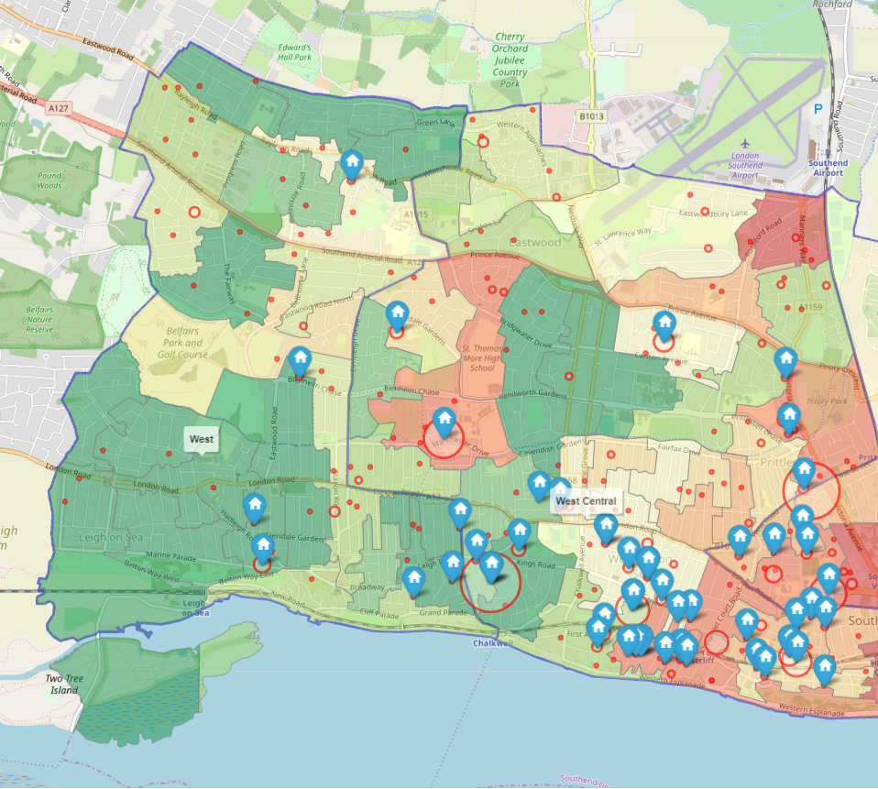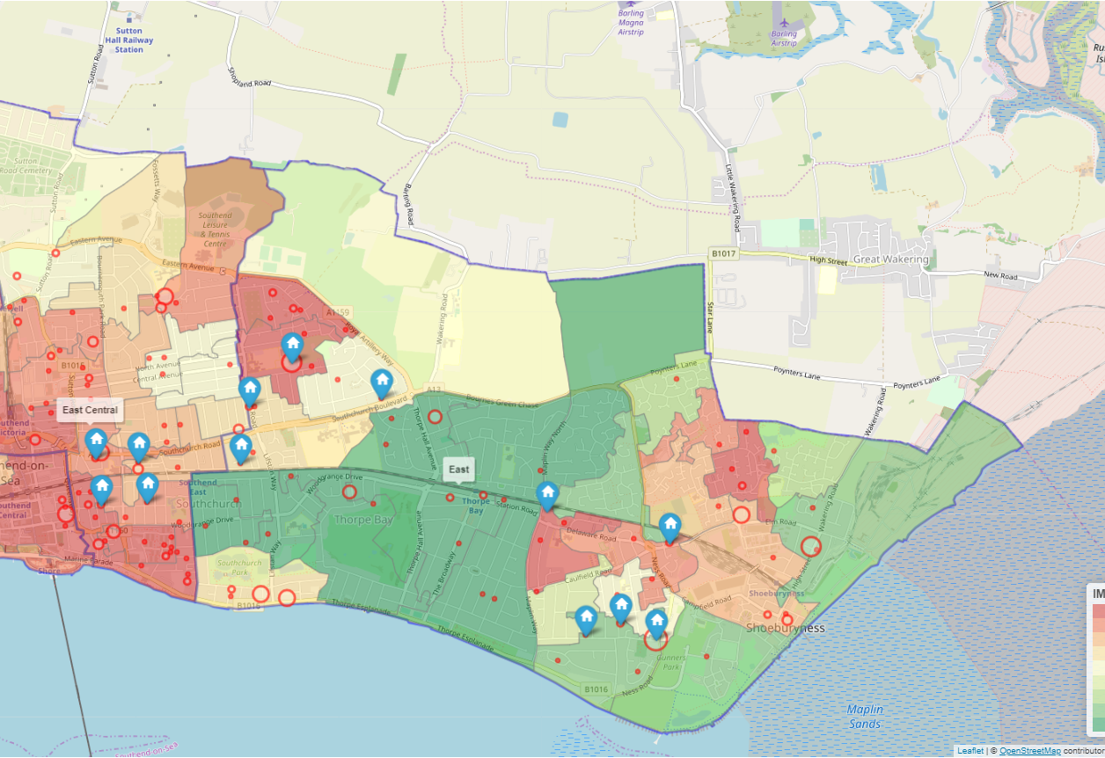

Concerns Raised

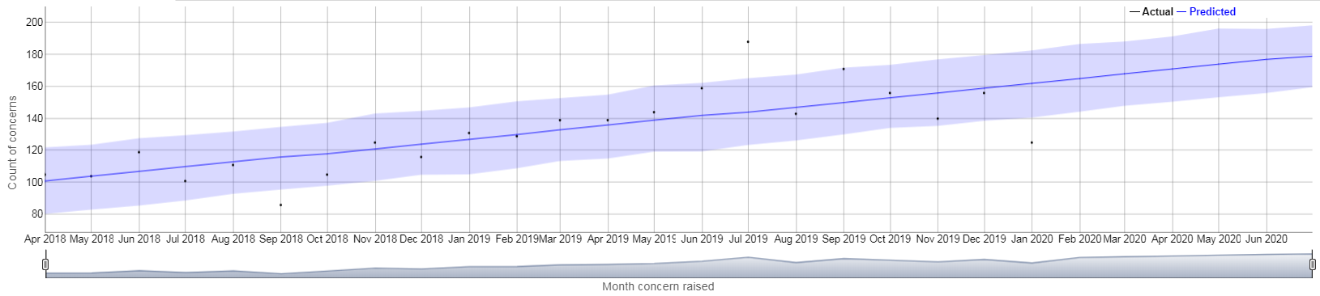

Concerns Raised

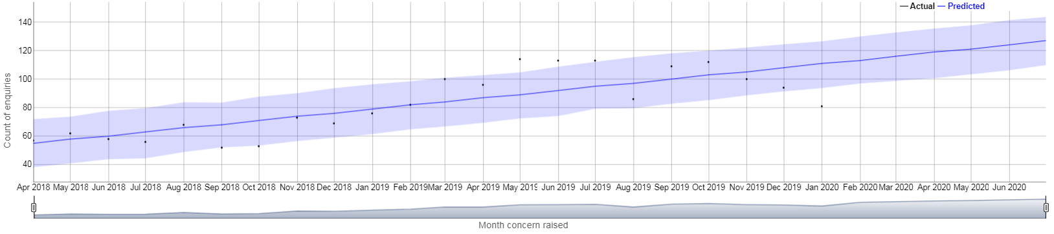

Concerns Raised (With no action)

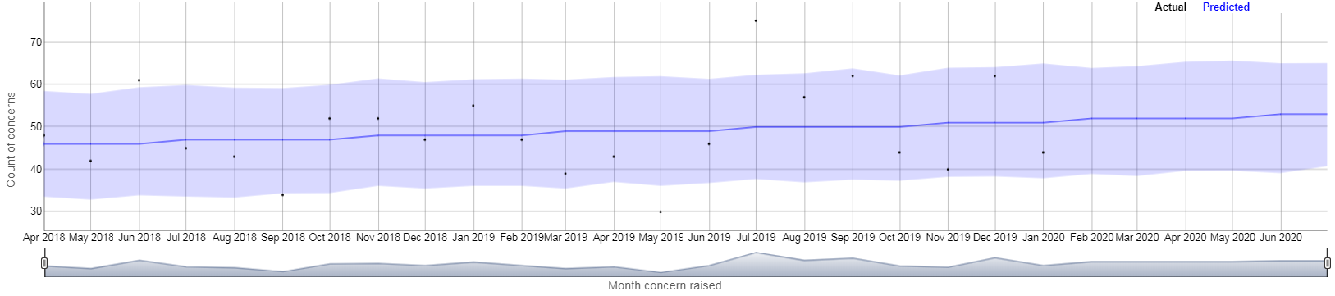

Conversion (Concerns to Enquiries)

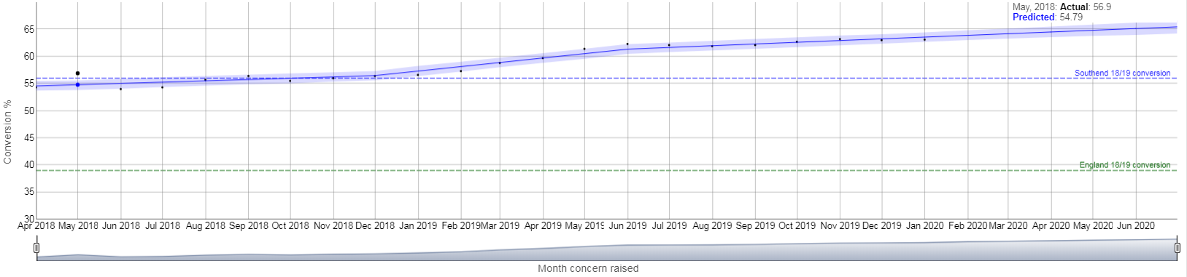

Enquiries by Month, Type and Source

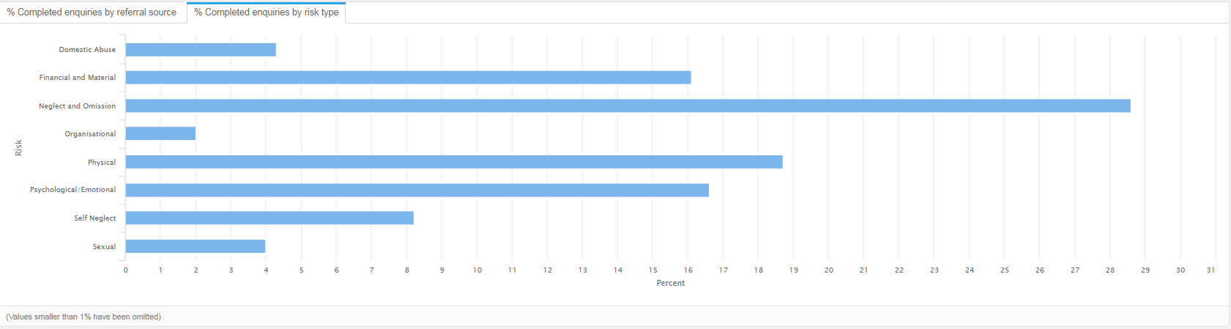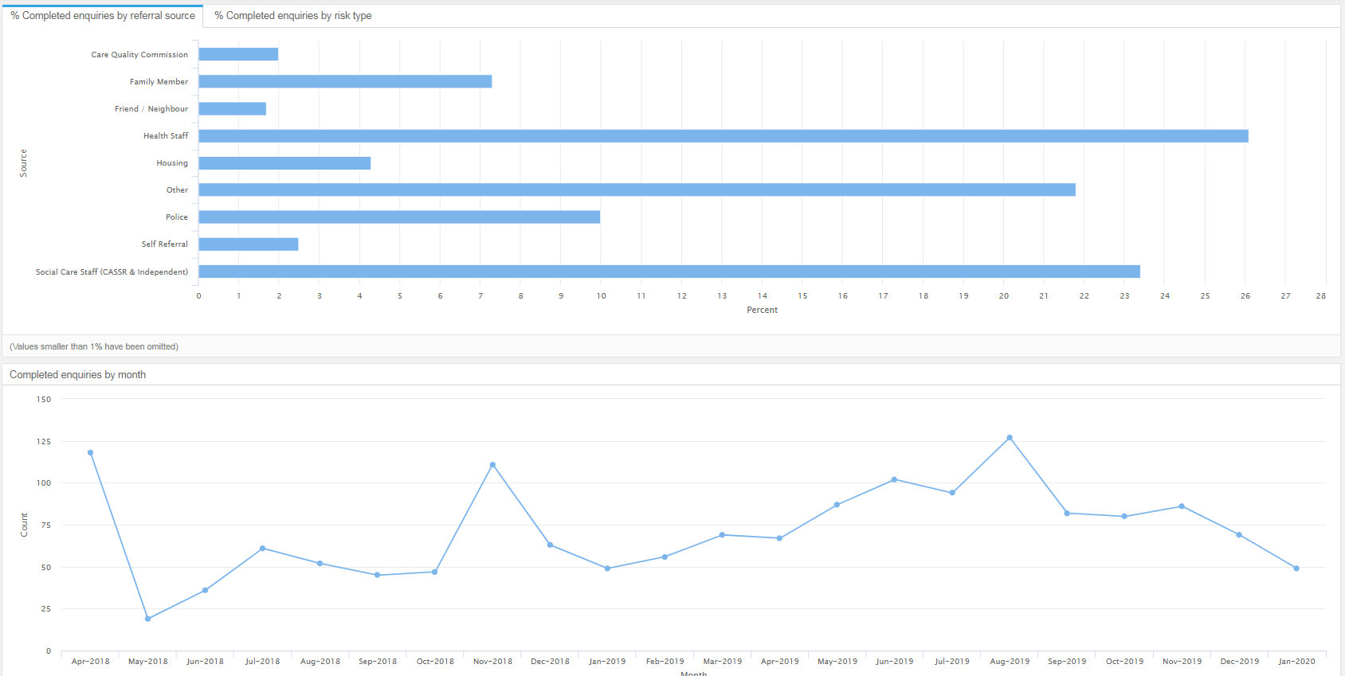

## Appendix 15– Children - Contextual Data

Safeguarding Enquires in Southend 2019-20

* Contacts received in Jan 2019 – Jan 2020 (Map Colour)
* Referrals resulting in SSWA (Size of Circle shows relative number)

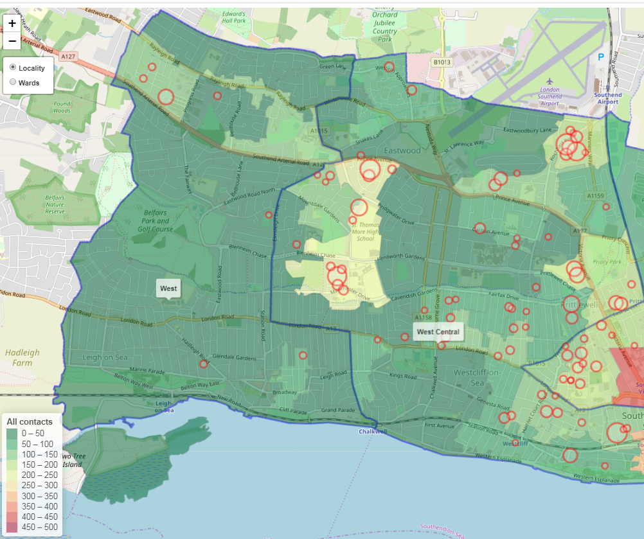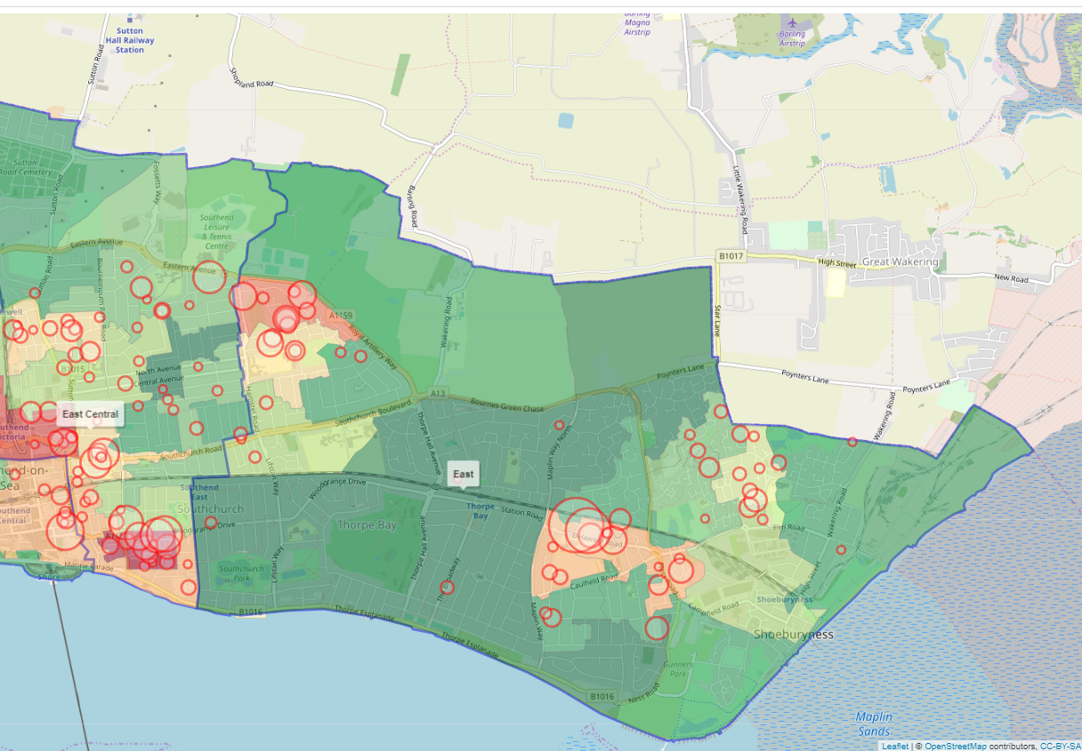

Rate of referrals per 10,000 children (Benchmark)

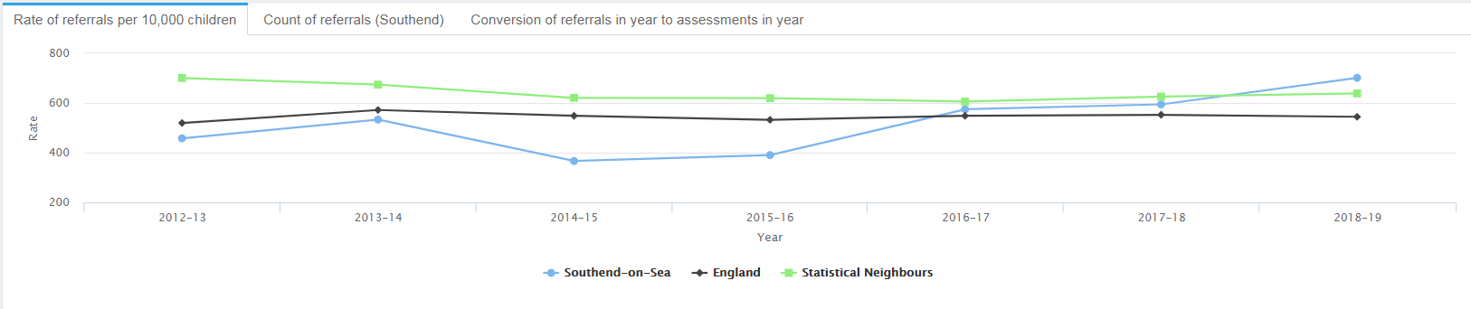

Rate of referrals per 10,000 children (Benchmark)

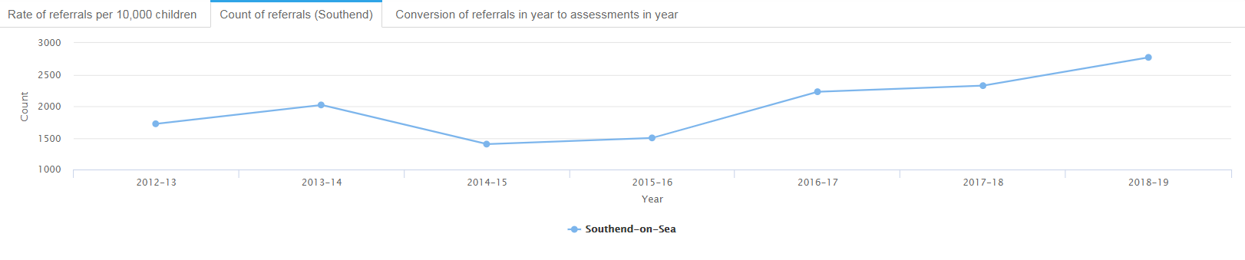

Conversion of Referrals in Year to Assessments Year

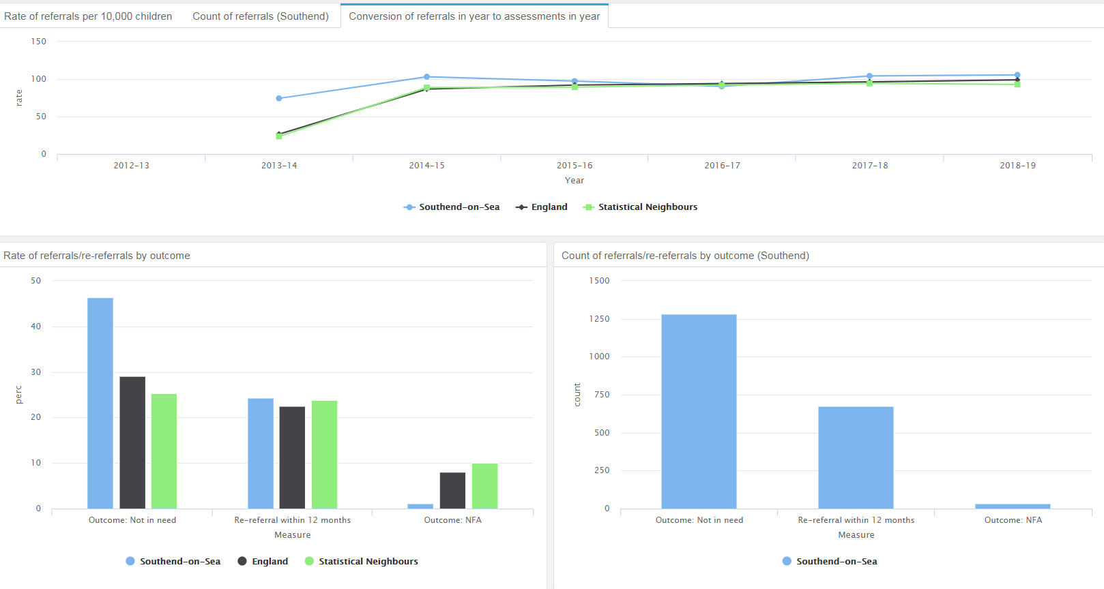

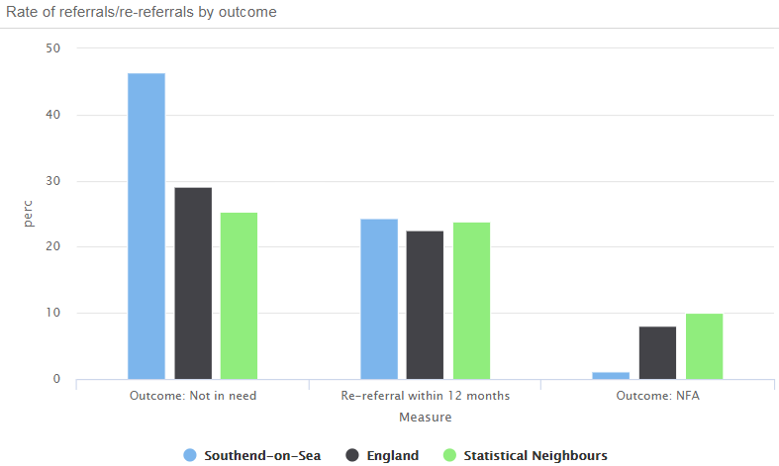

Count of Monthly Contacts

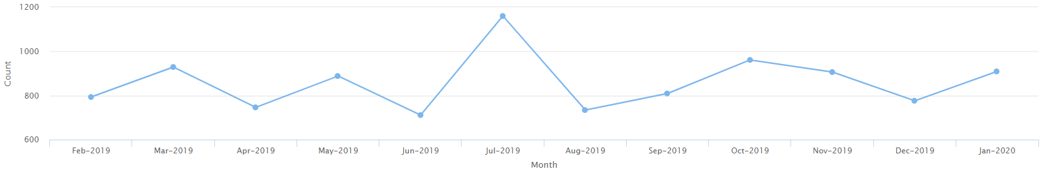

Rate of Contacts per 10,000 children

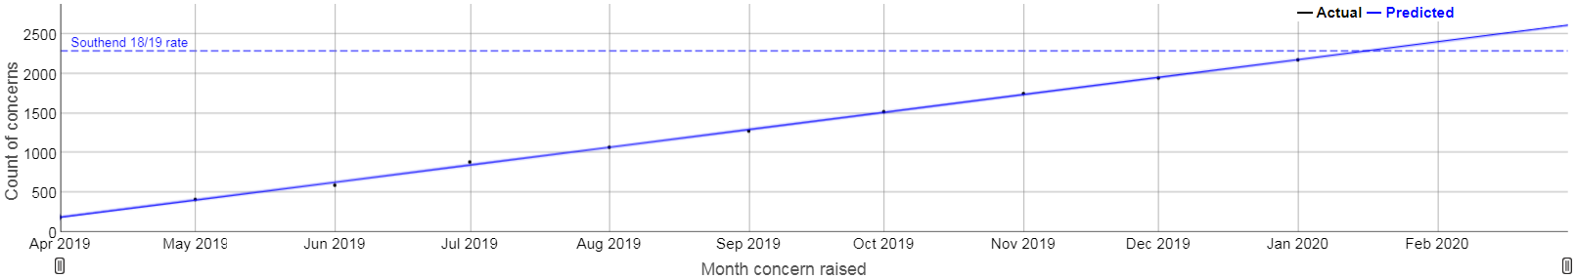

Monthly conversion of Contacts to Referrals (%)

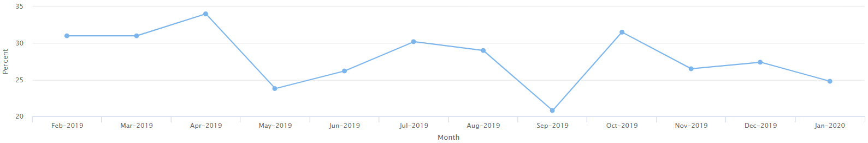

Monthly Contact by Source (%)

